**Hotel Database Management System**

**Introduction:**

The advanced hotel management system created to transform and improve hotels' operating capabilities within the globe. Hotel DB is a flexible platform that combines many hotel management aspects into a single, user-friendly interface. Hotel Data Base offers a wide variety of features needed for effective hotel administration, including staff management, reservation processing for guests, and customizable facilities. We used to react, Node.js, Express, CSS and MySQL technologies for this project. We Successfully build the user interface for the Hotel Database Management system.

**Decoding the Coding Steps:**

* Use the terminal to type npm install mysql2 to make sure the mysql2 package is installed in the project.
* Using the createConnection method, establish a new connection instance and supply the required database credentials (host, user, password, and database name).
* To establish a connection, use the "connect" function on our database connection instance.

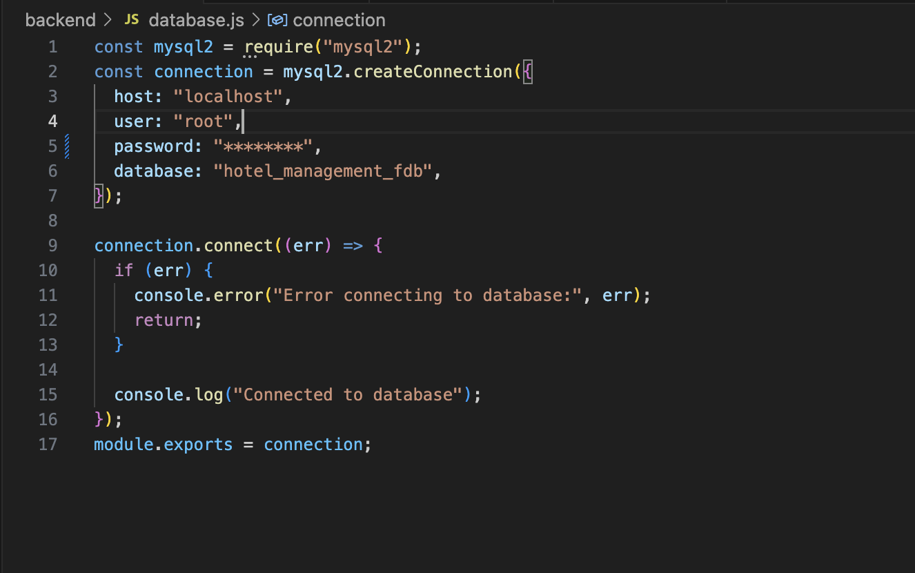

**Entity Relationship Diagram:**

We created different suitable entities and attributes for this project.

**Hotel:**

Captures all of the relevant information about a hotel, such as its name, unique ID, and operational features like pictures, phone numbers, and business hours.

**Location:**

Includes geographic data that differs by region, pincode, location, city, and country for many organizations.

**Amenities:**

lists all the facilities that are available, in addition to a unique number, name, description, accessible details, guidelines, price, and contact information for each facility.

**Rooms:**

Describes specific hotel rooms, including their level, number, additional features, and occupancy status.

**Room Type:**

Classifies rooms according to their type and includes information about them including name, description, capacity, type of bed, number of beds, cost, and cancellation policy.

**Booking:**

Keeps track of information regarding guests' visits, such as arrival and departure dates, total price, number of nights, and connections to the visitor and room entities.

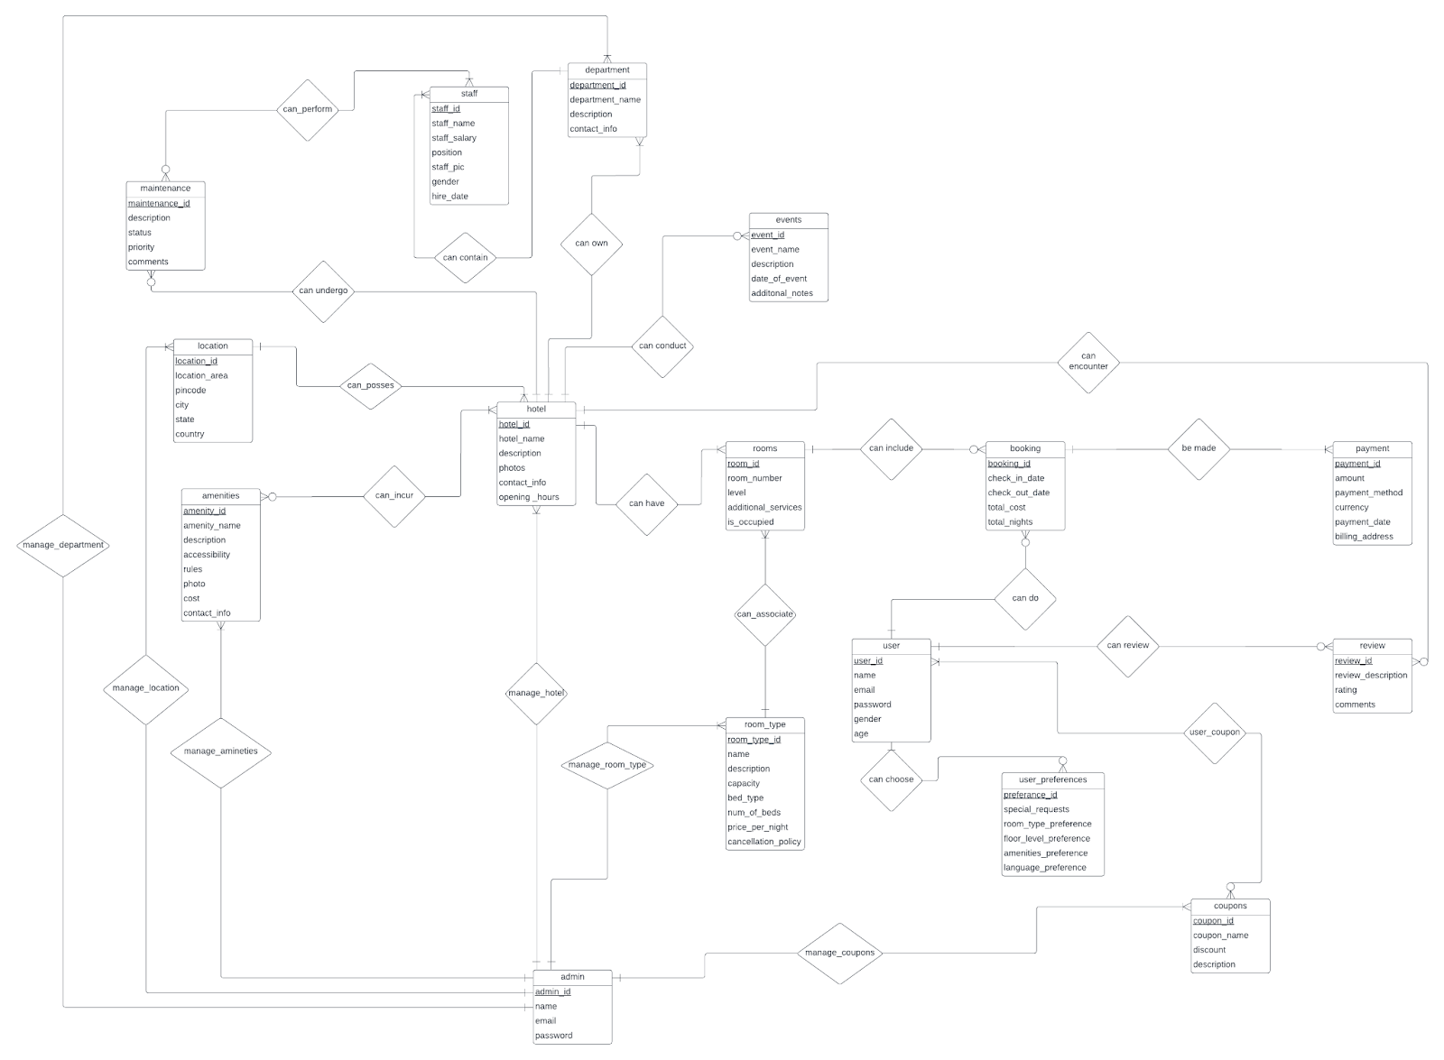

**User:**

Contains information on a system user or guest, such as name, email address, encrypted password, age, and gender.

**Admin:**

Represents system administrators by using an encrypted password, name, and email address.

**Admin Table:**

Below are the details for the admin table.

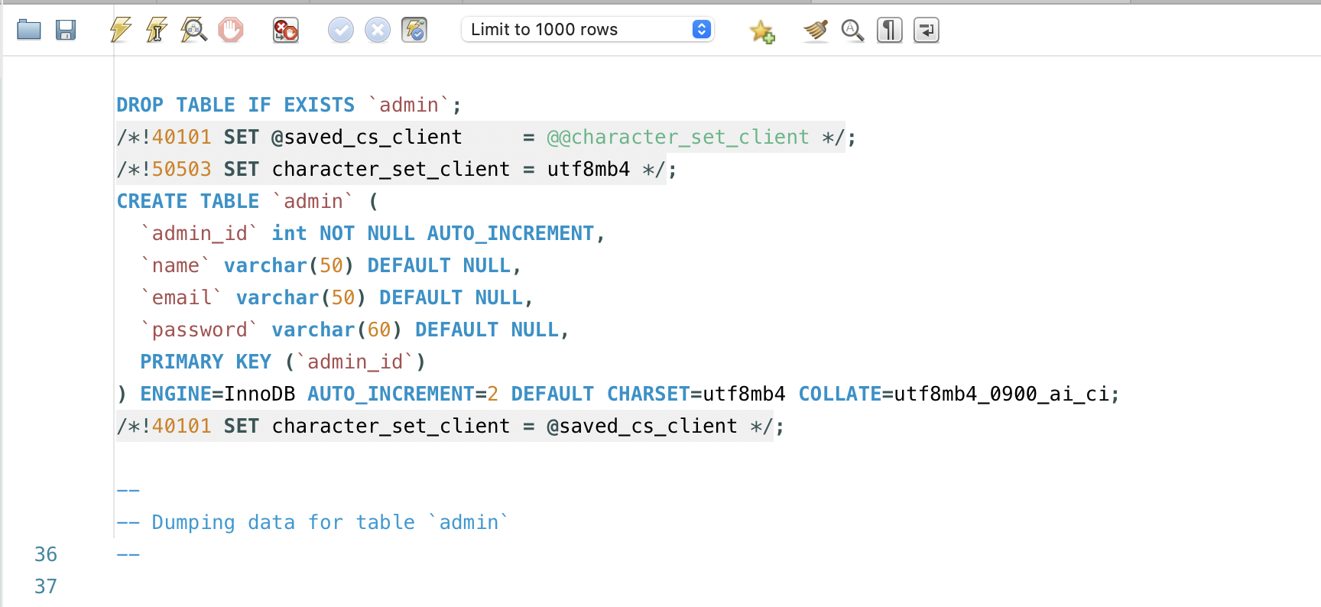

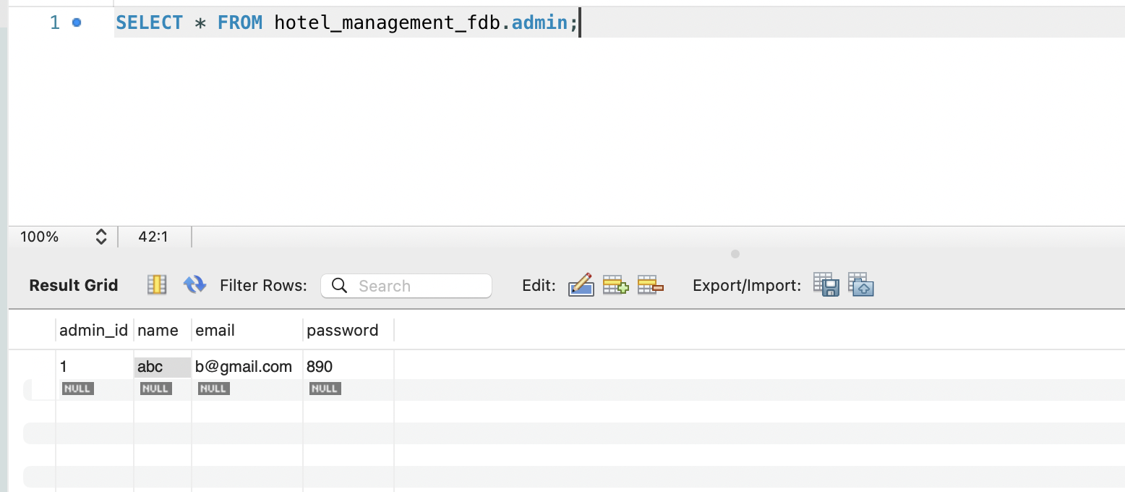

**Amenities Table:**

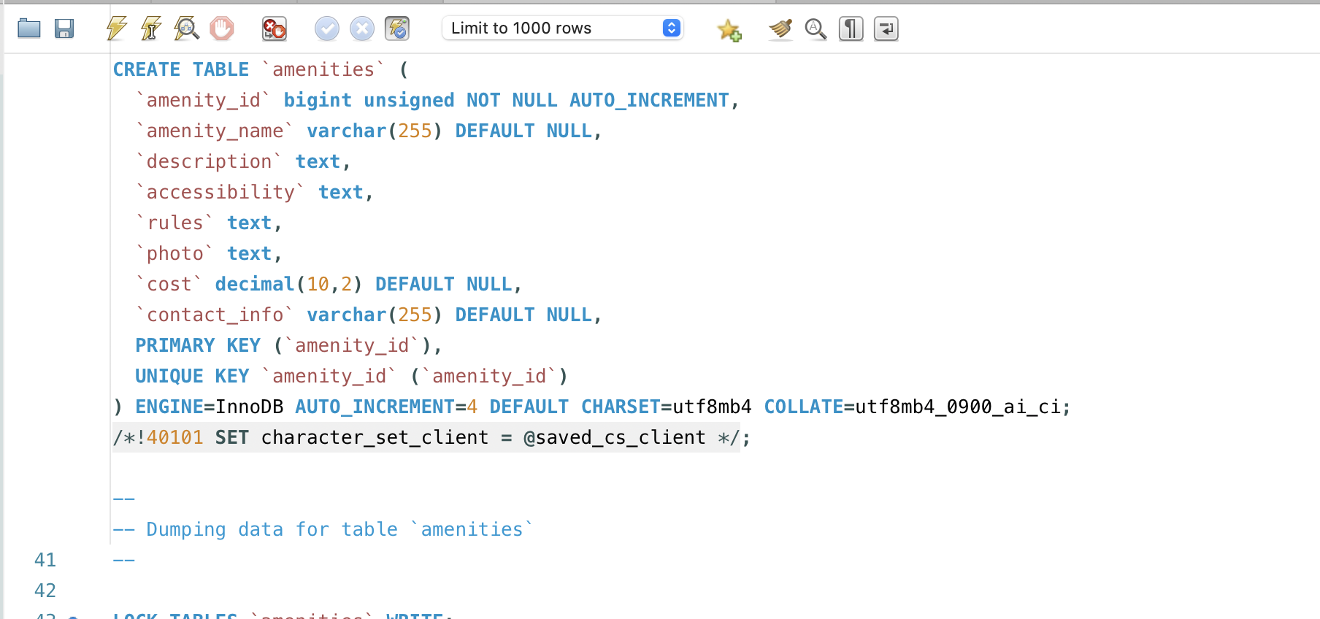

Below is the data for the amenities table.

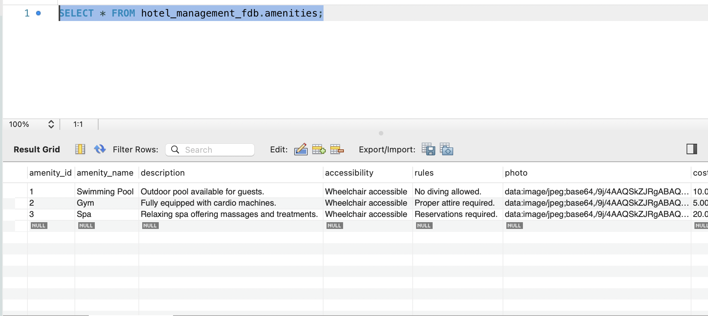

**Hotel_Amenities:**

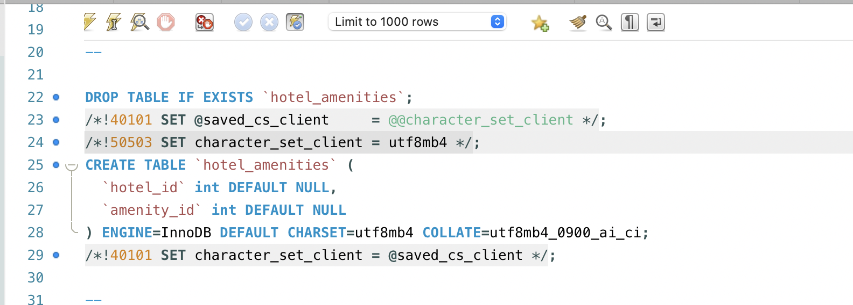

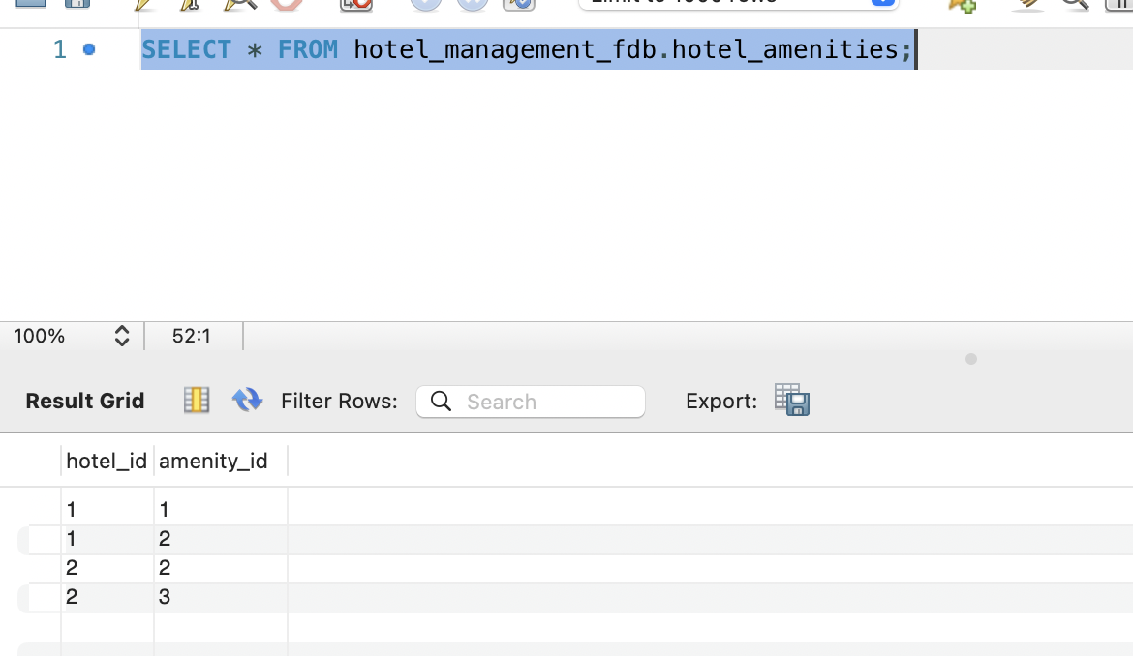

**Hotel Table:**

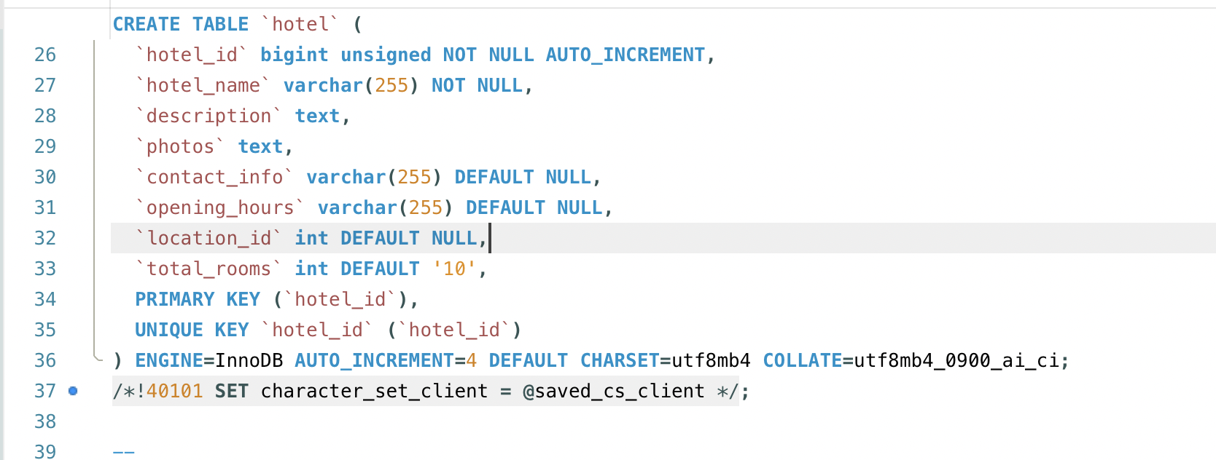

Attribute data in Hotel Entity.

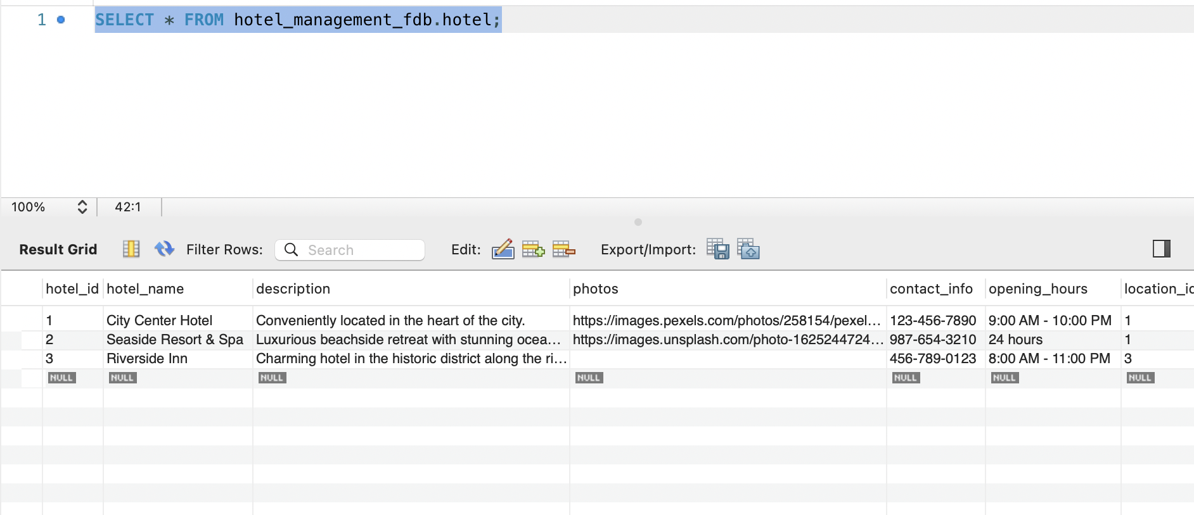

**Location Table:**

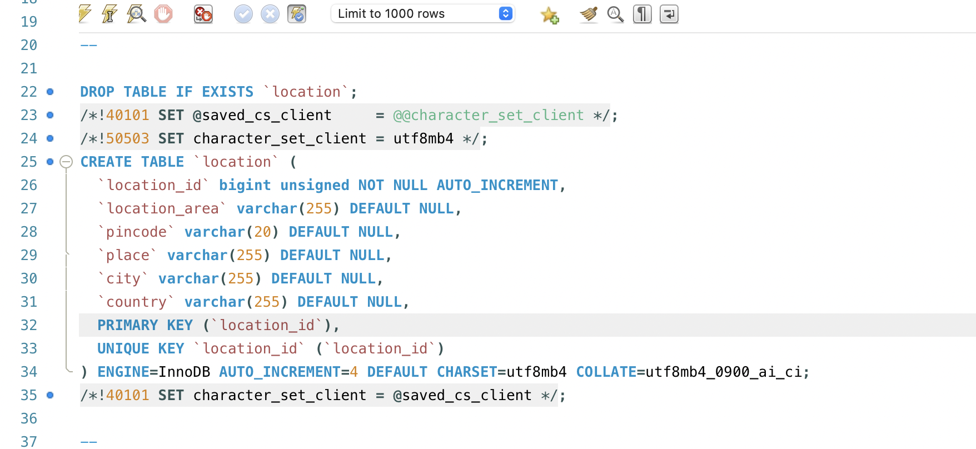

Here is data for location table.

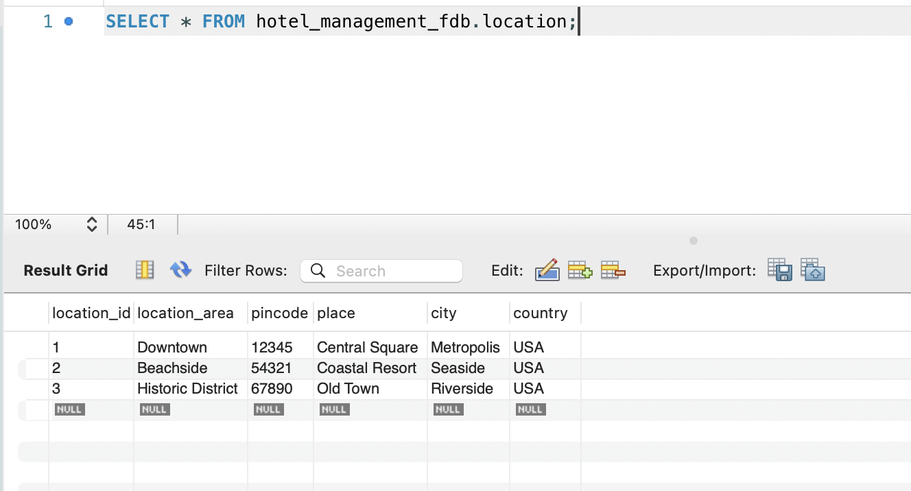

**Rooms Table:**

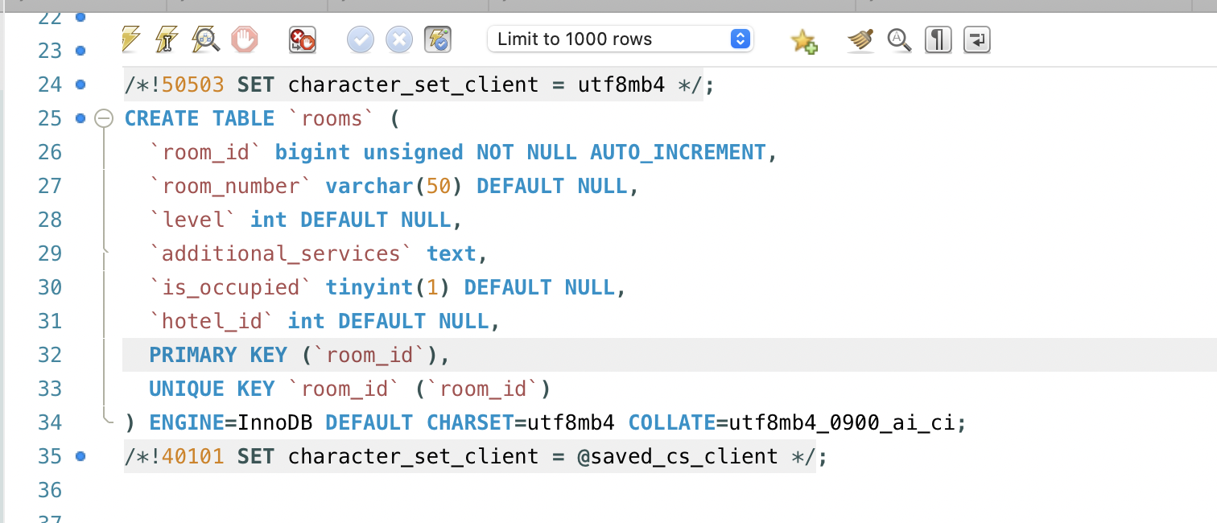

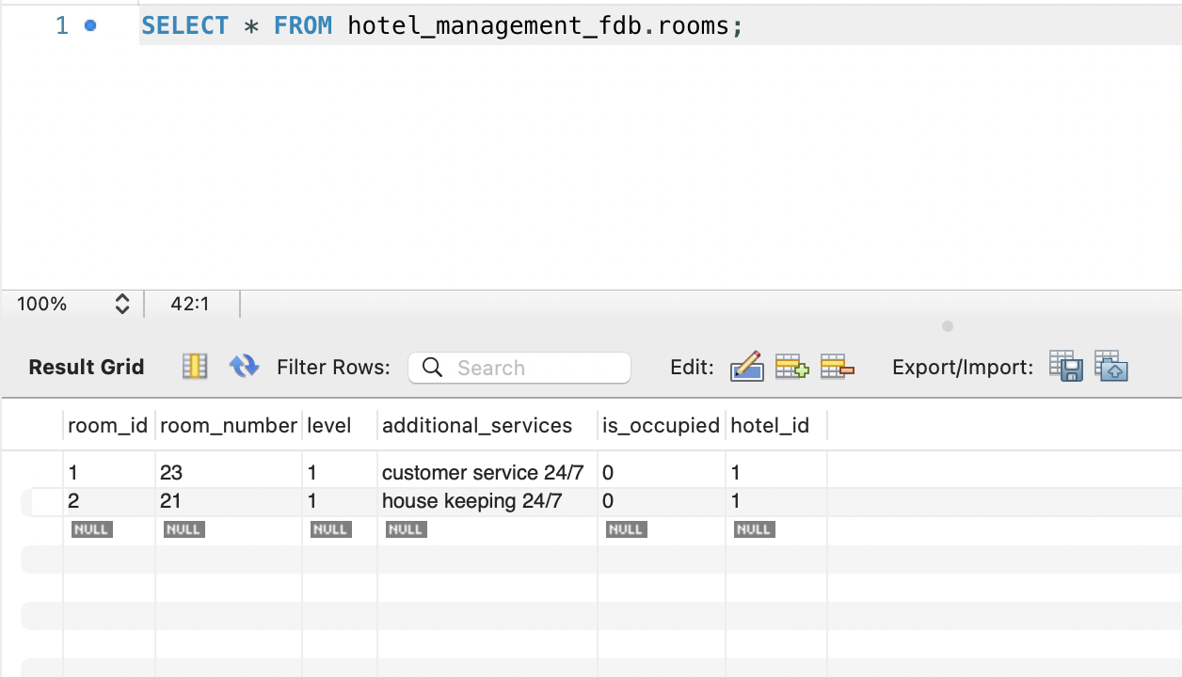

**Booking Table:**

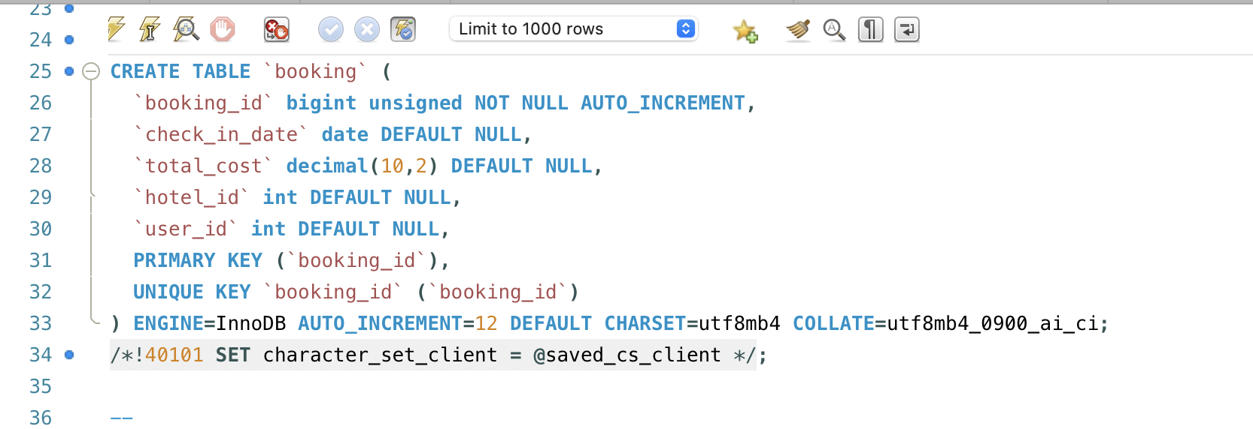

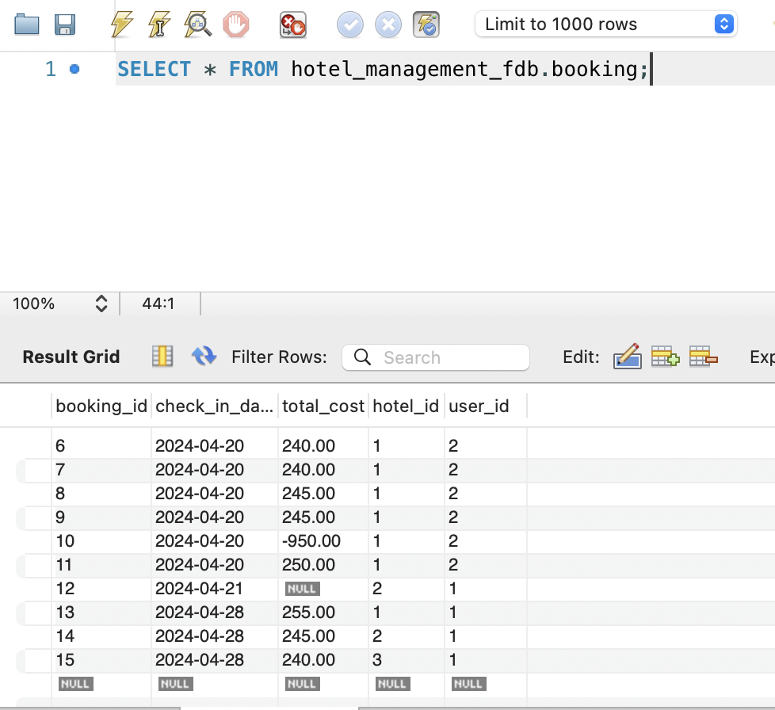

**User Table:**

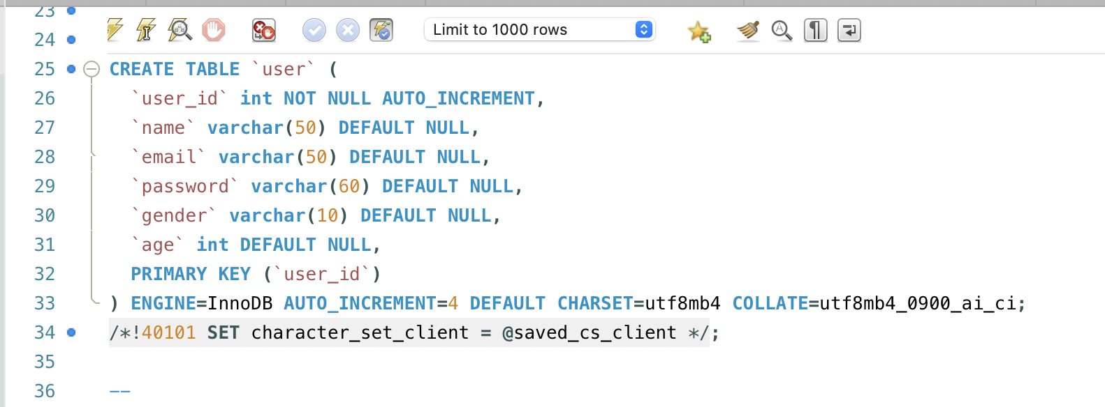

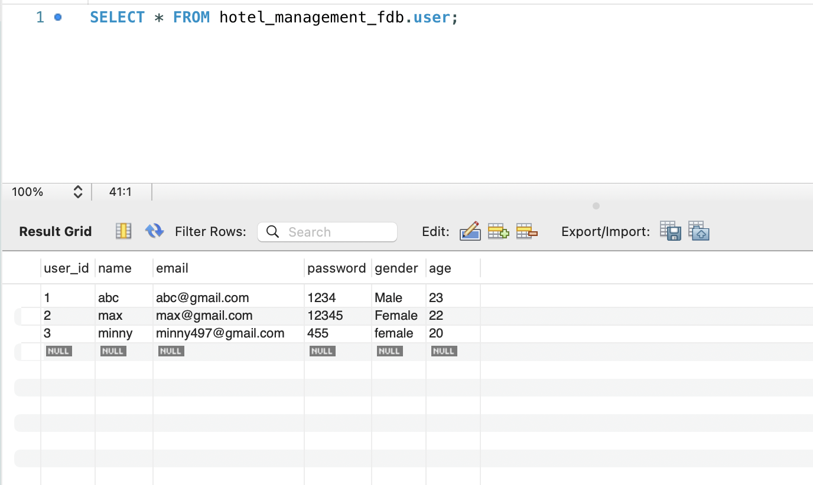

**Backend Code for the project**

**Admin Code:**

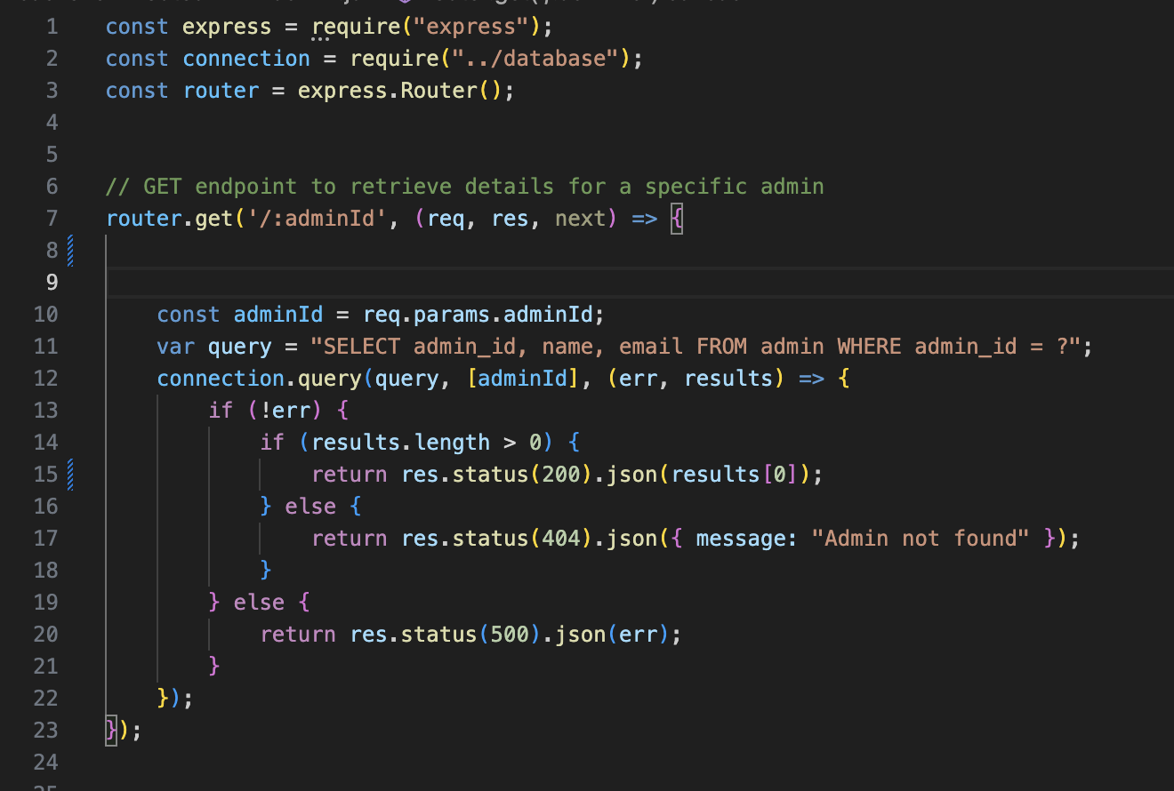

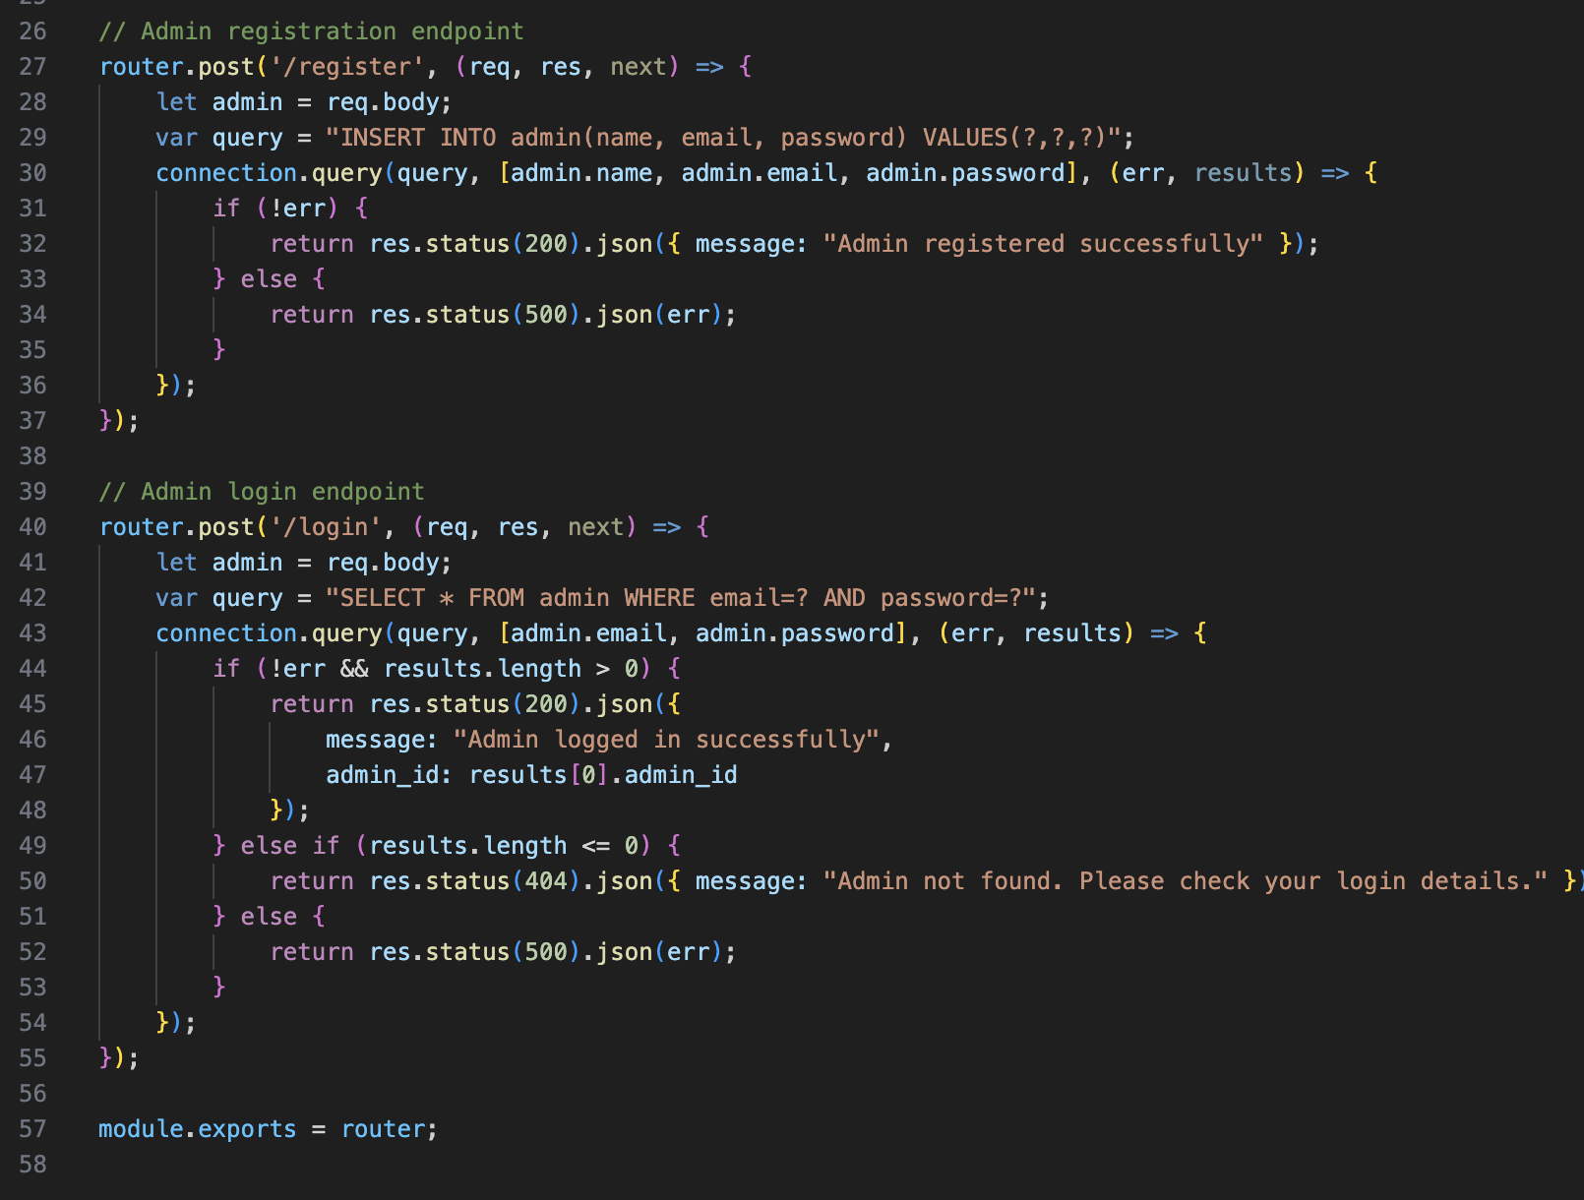

**Below are the get calls for Amenities.**

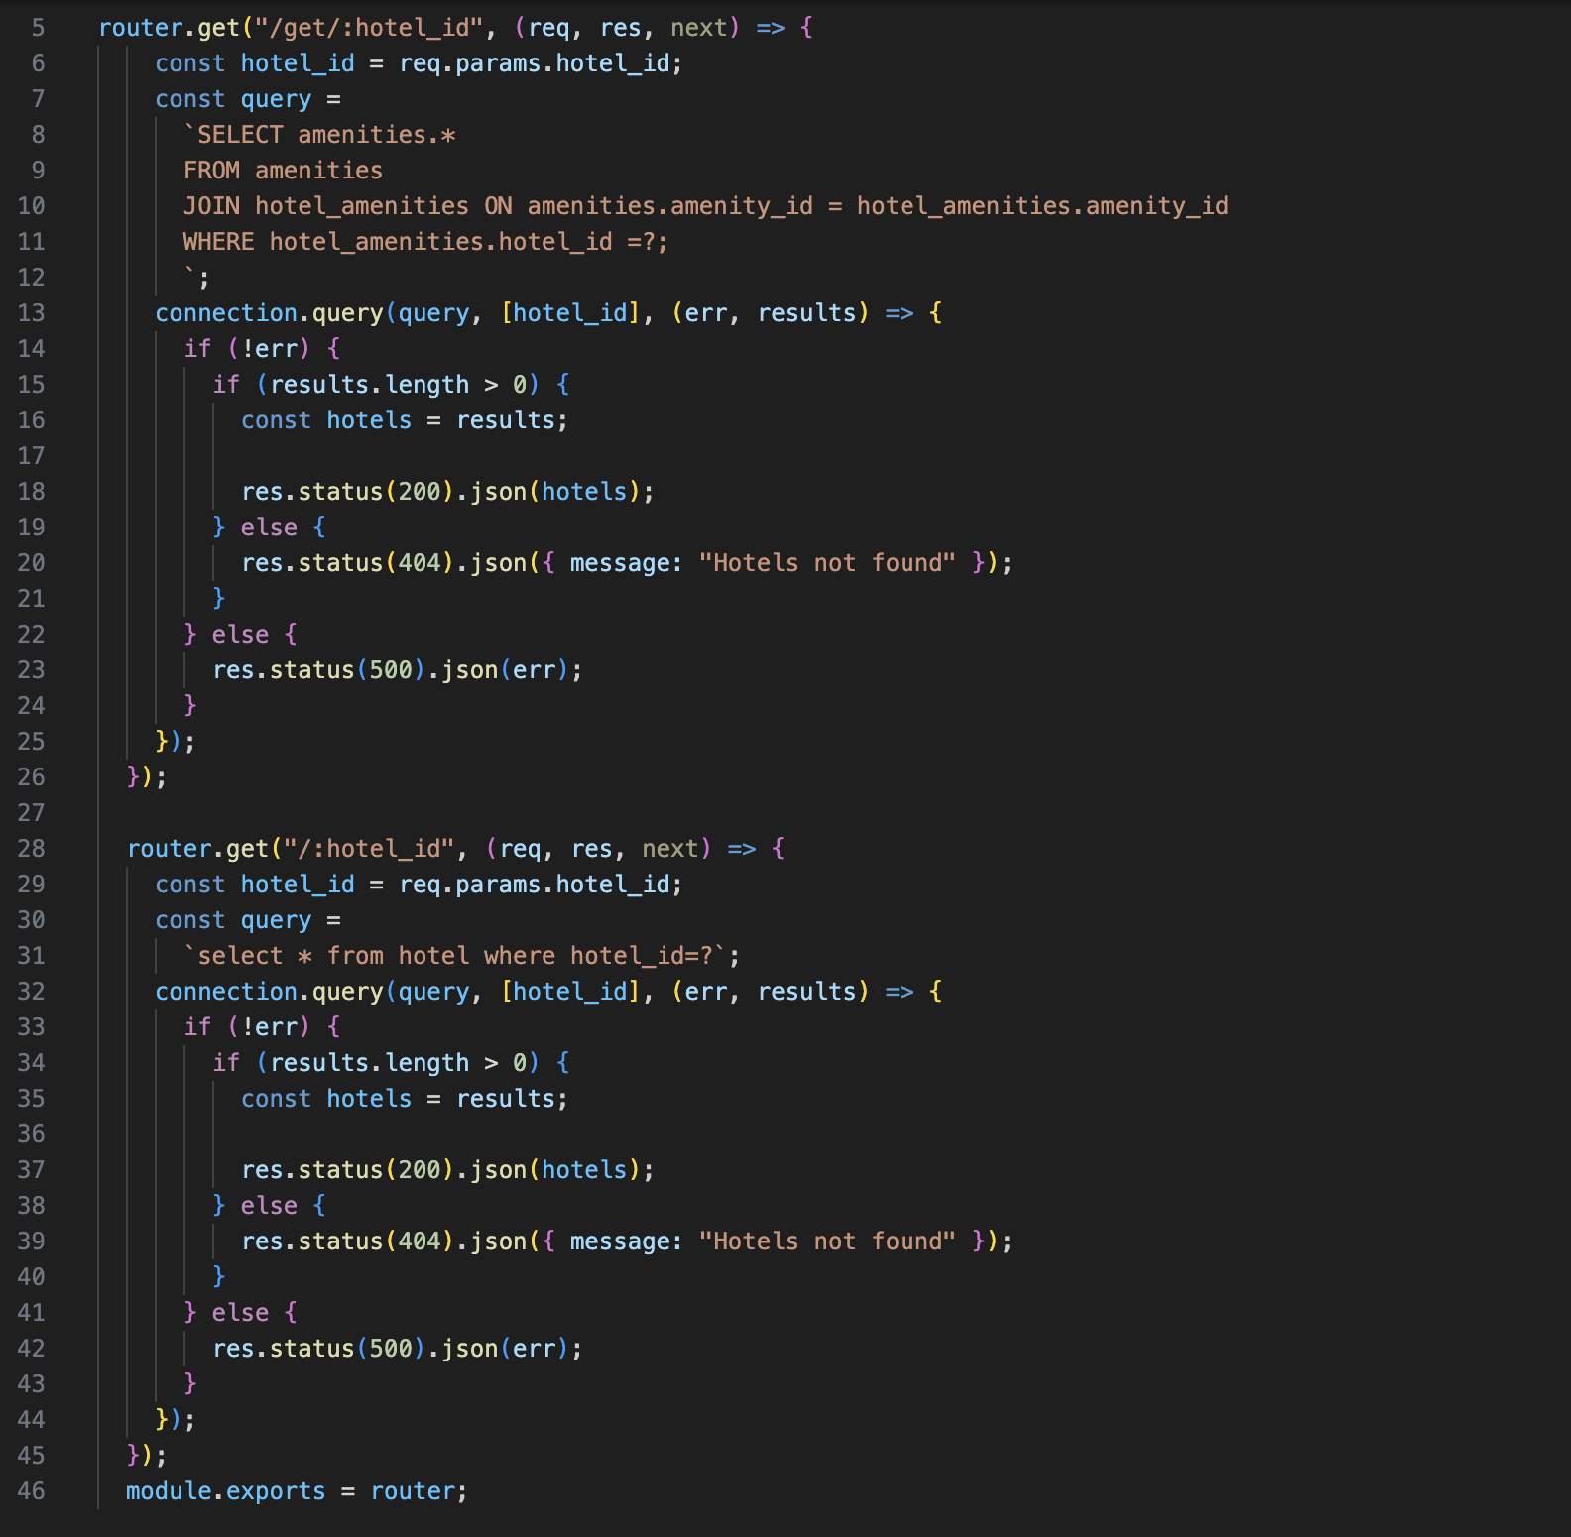

**Post and Get calls for Bookings.**

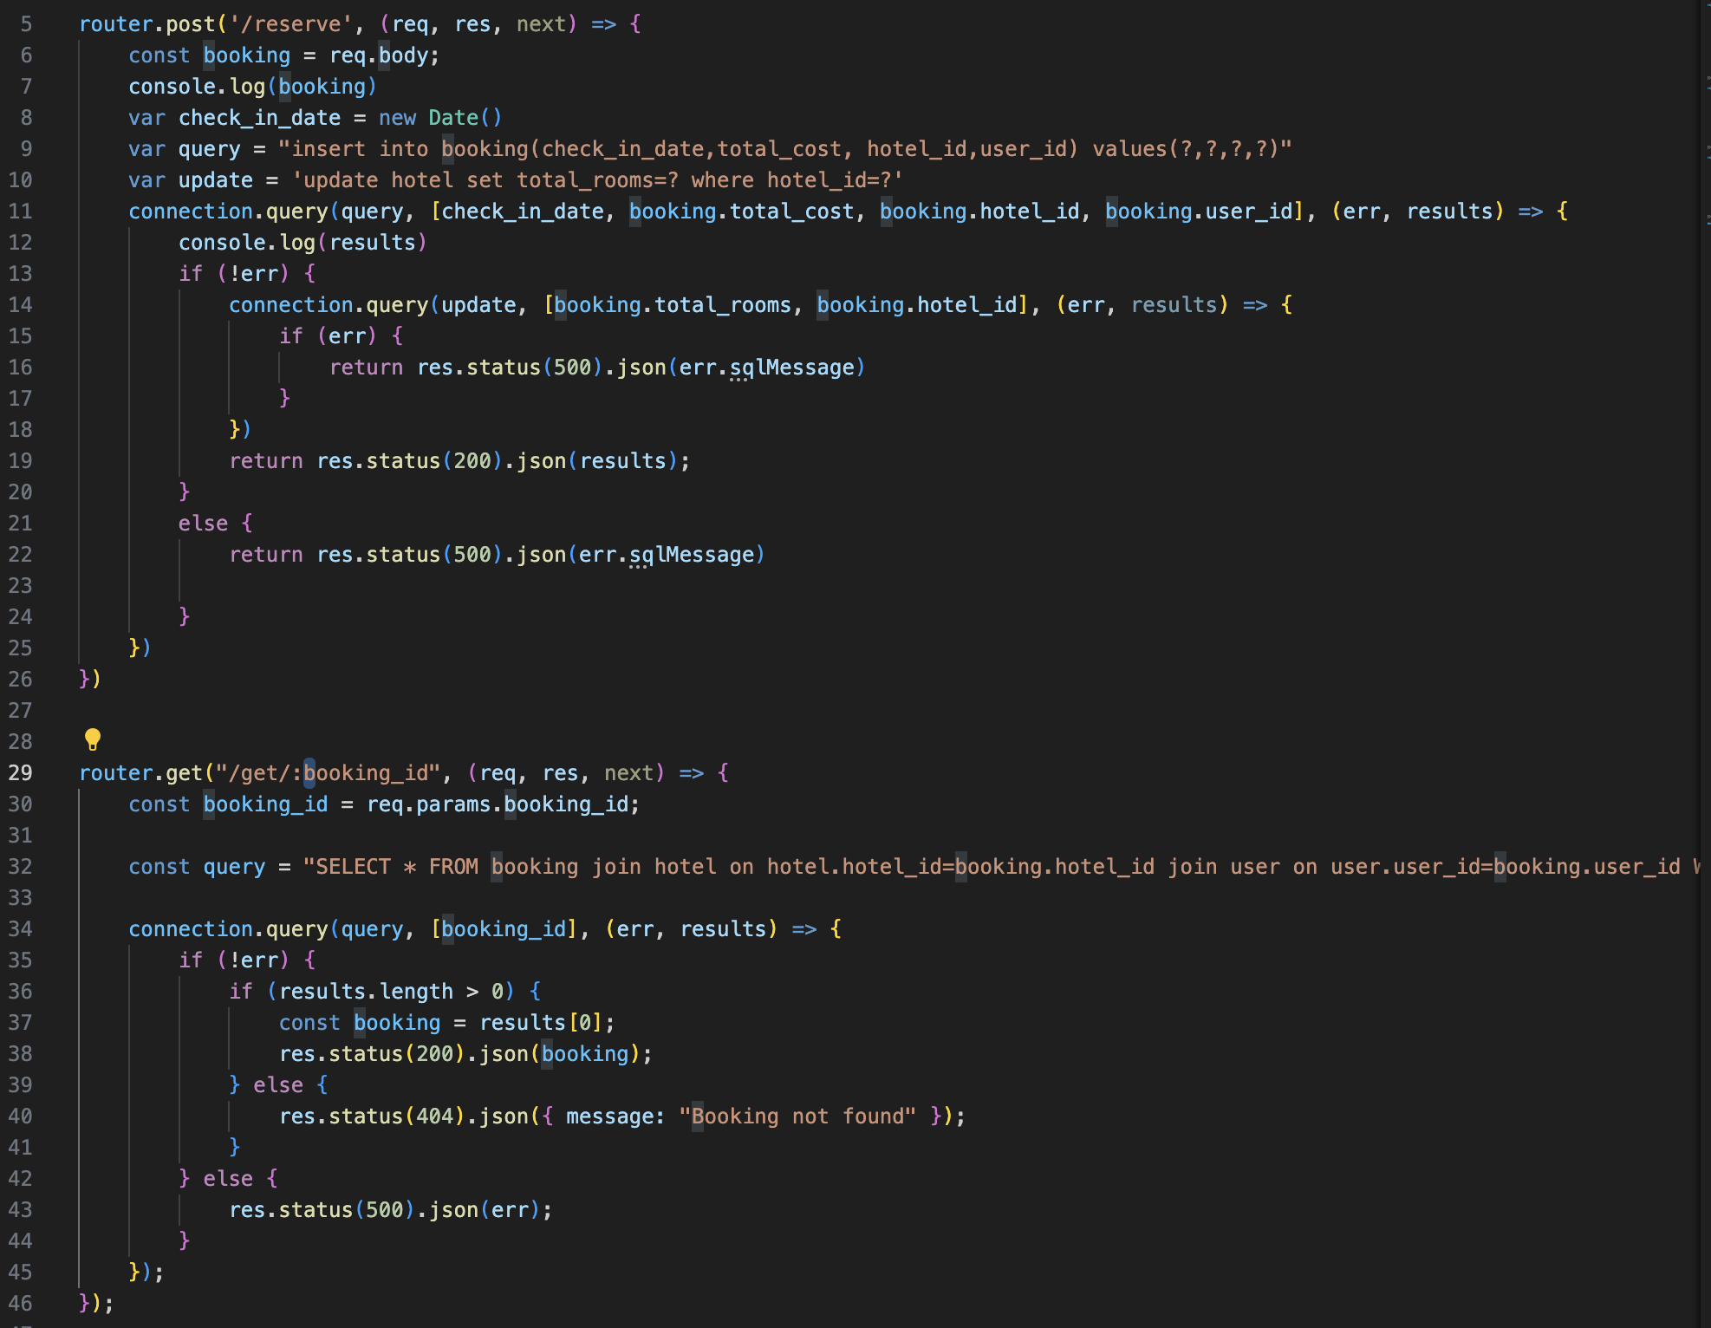

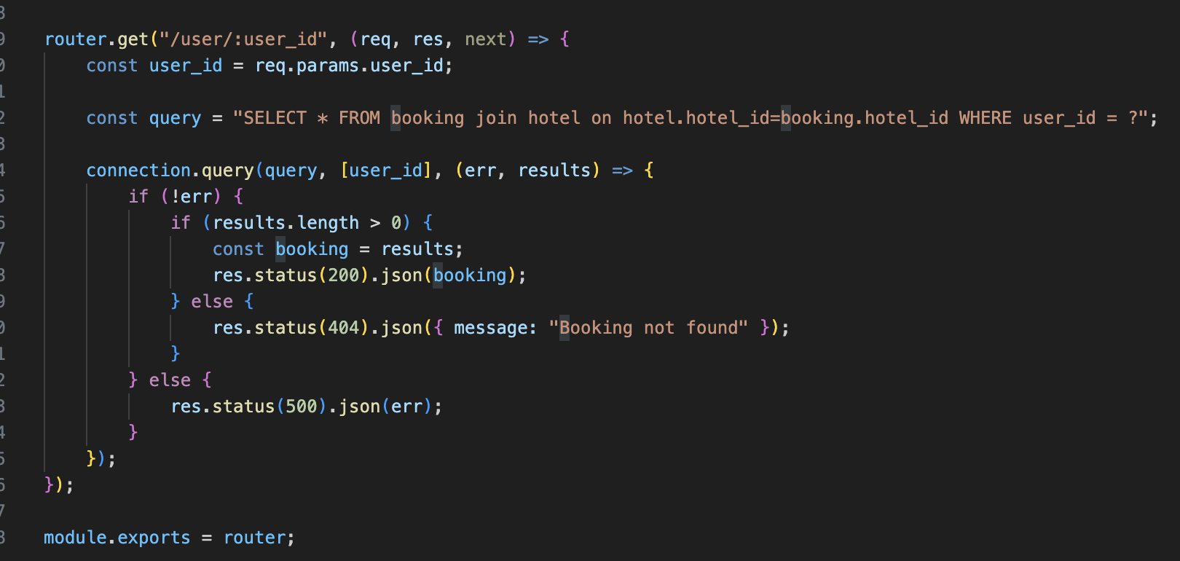

**Code for Coupons**

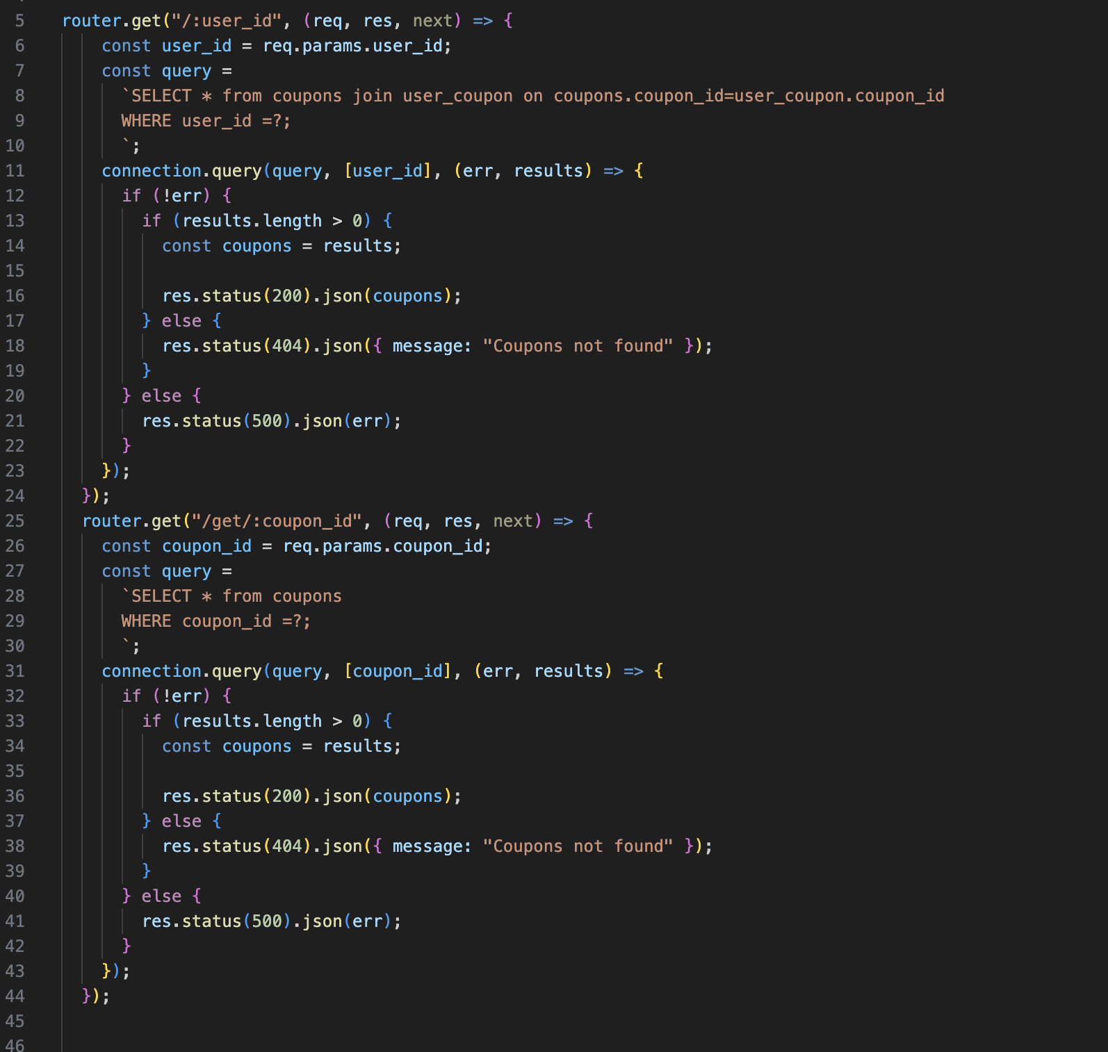

**Department code**

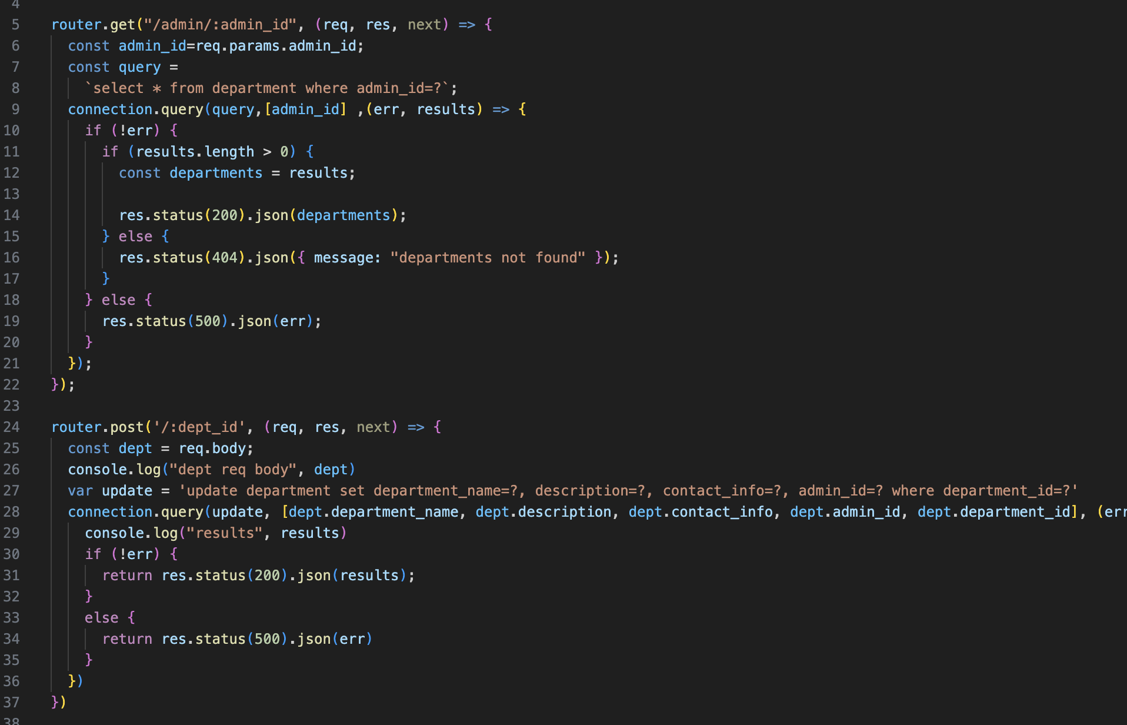

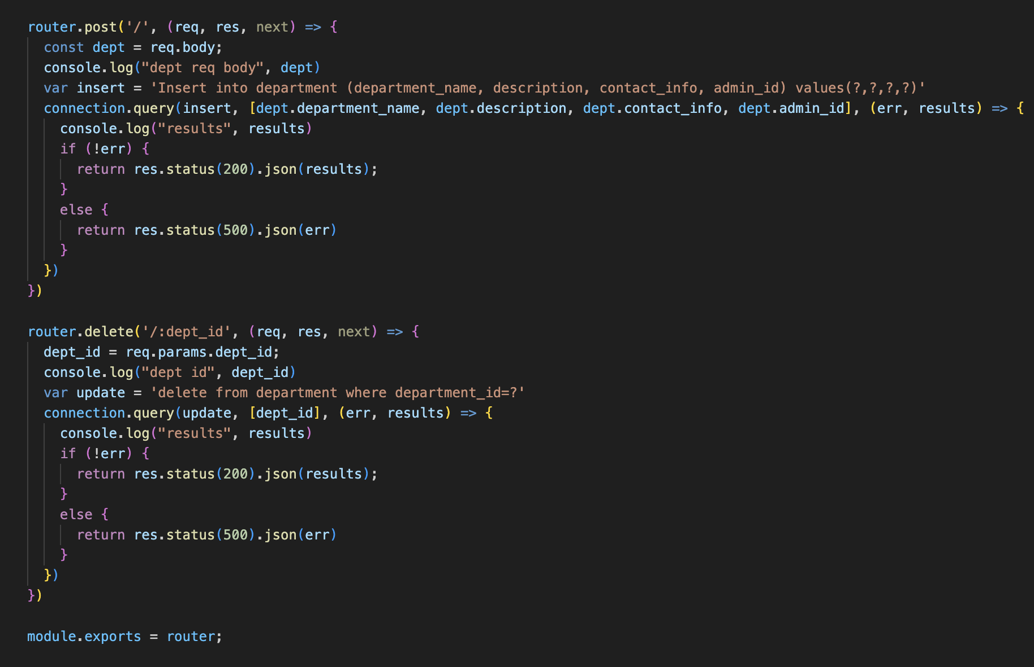

**Get call function for Events:**

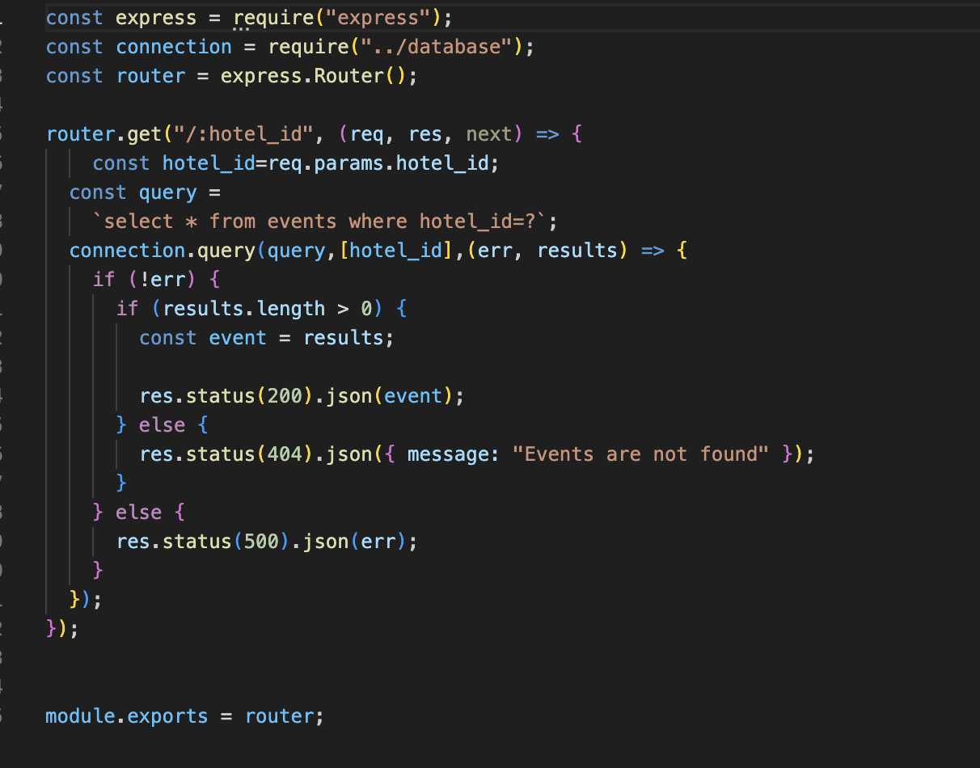

**Hotel Code:**

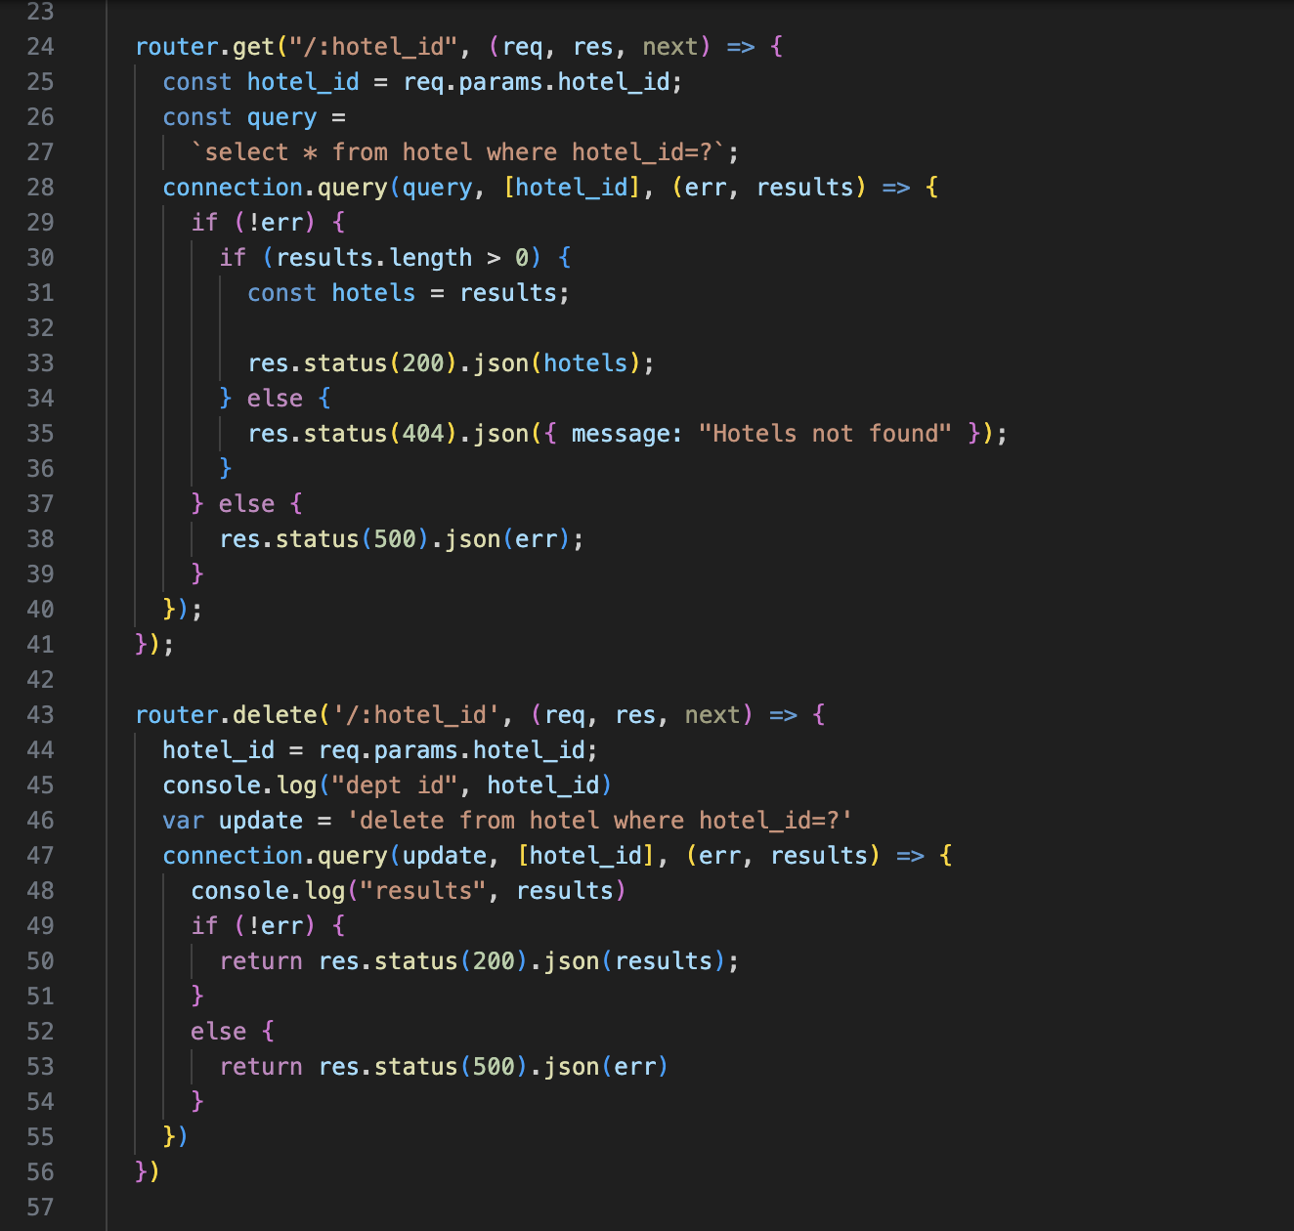

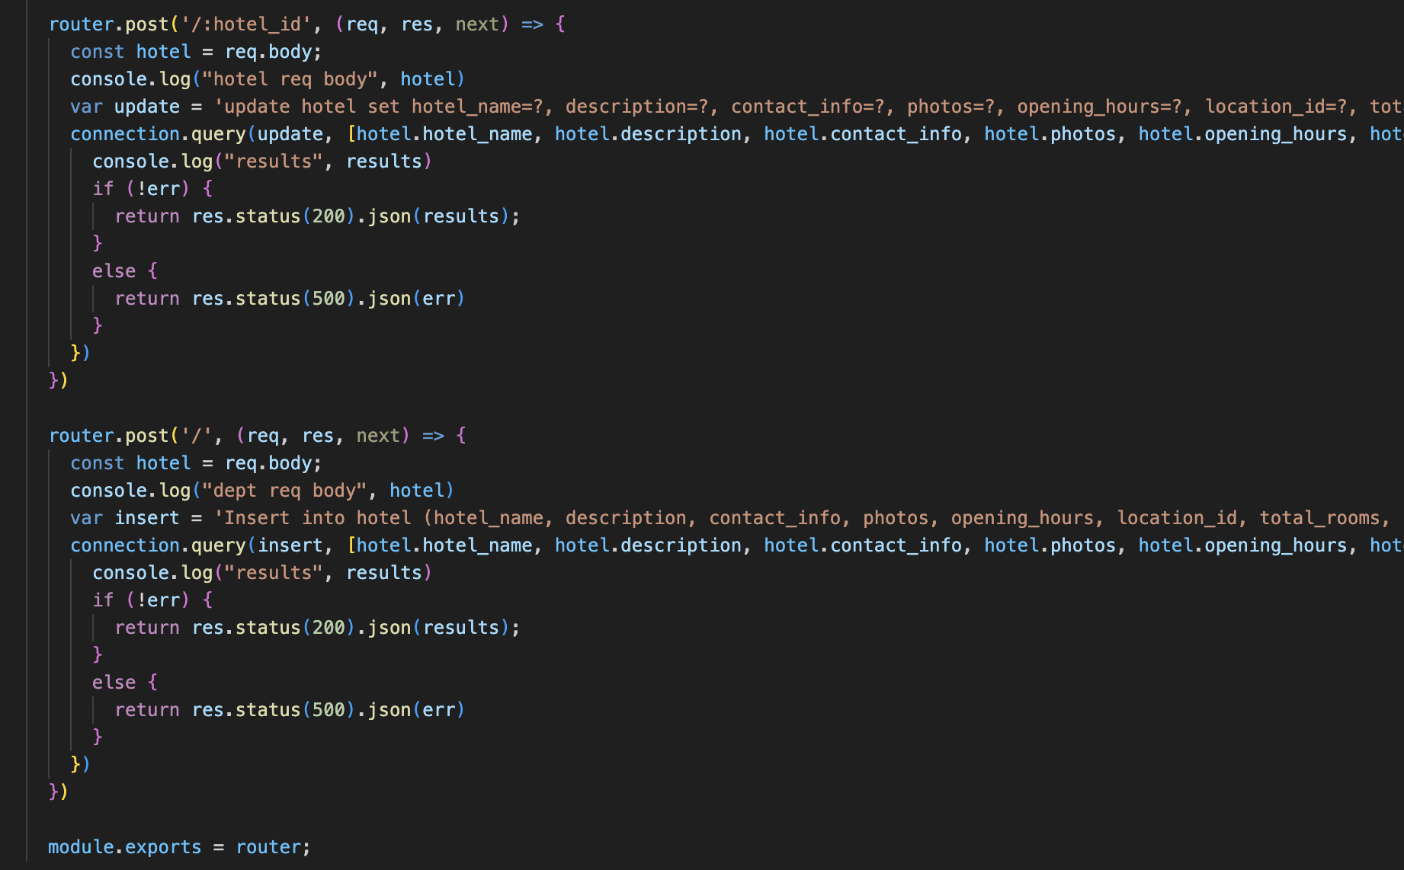

**Location:**

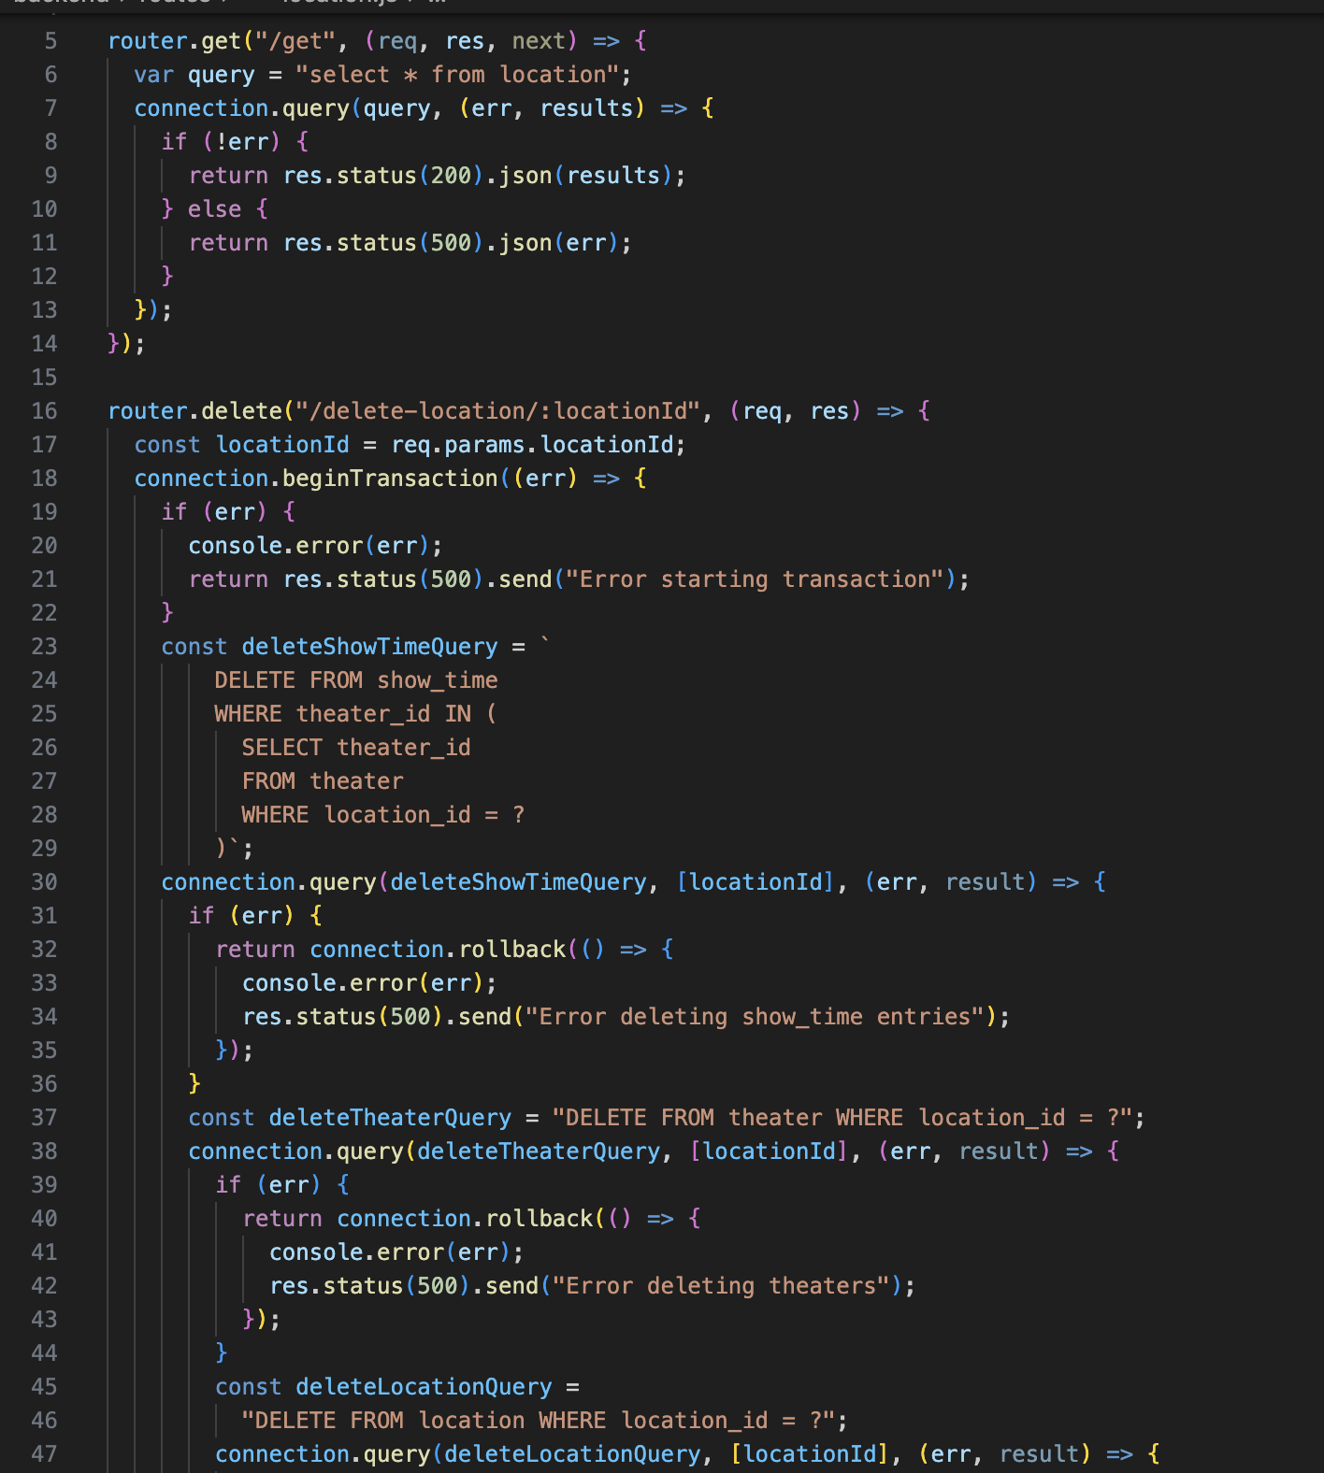

**User code:**

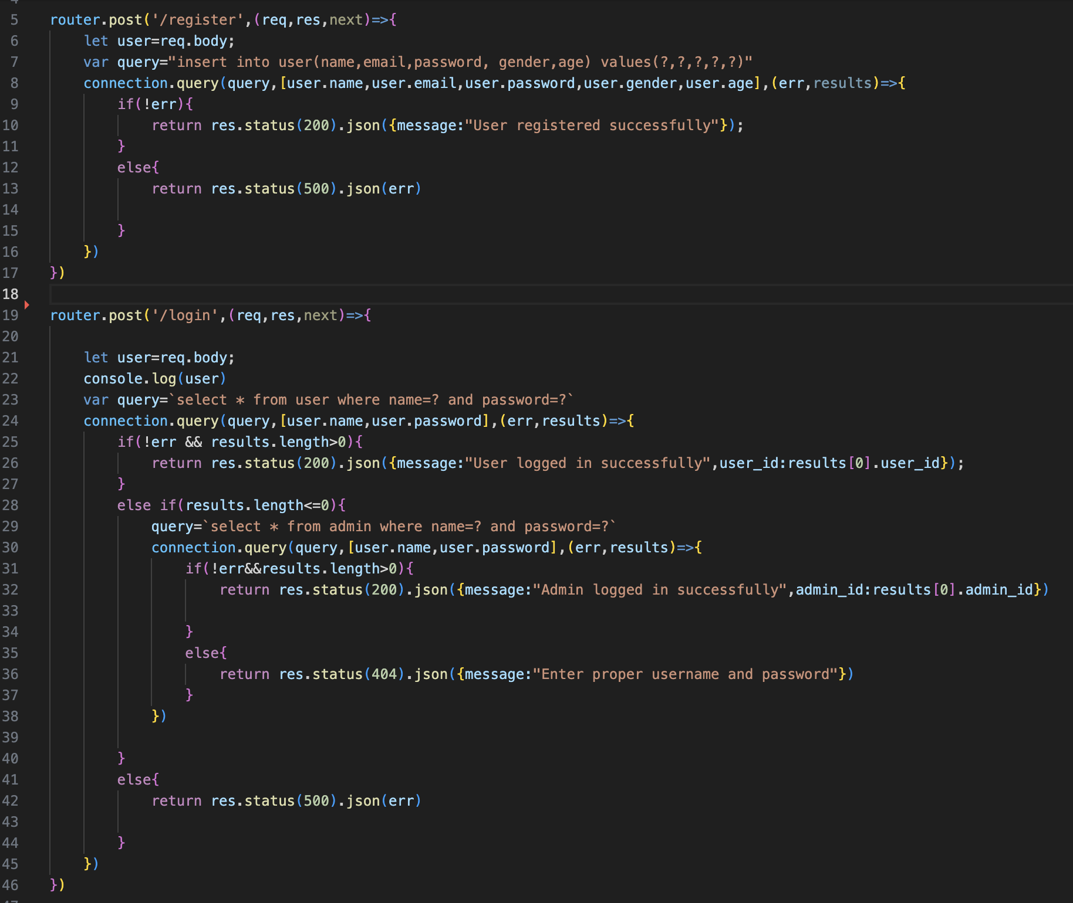

**User Interface for the Guests**

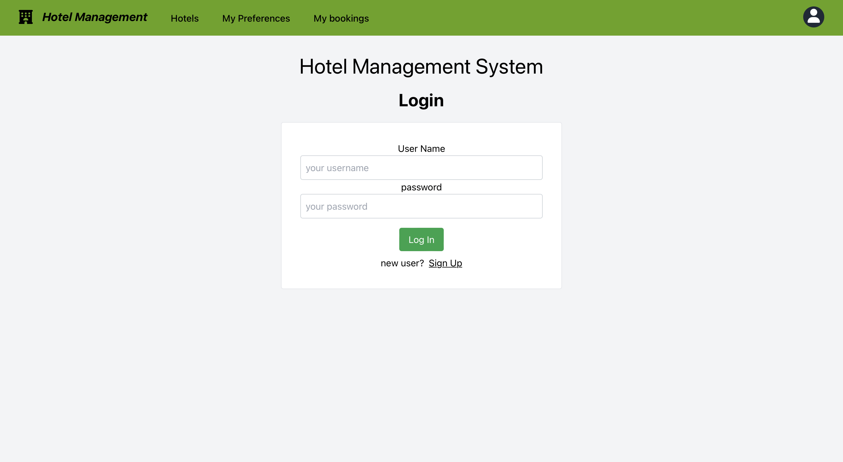

User login using the user credentials.

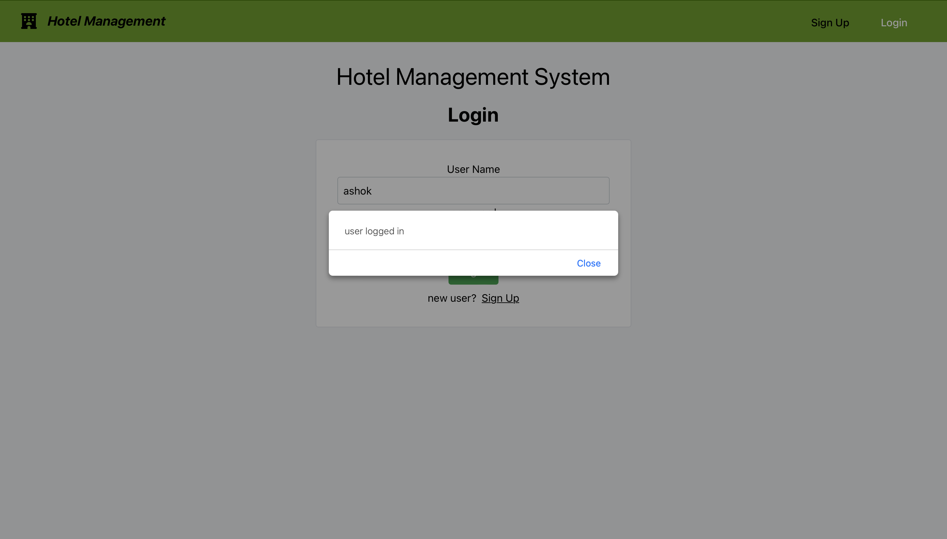

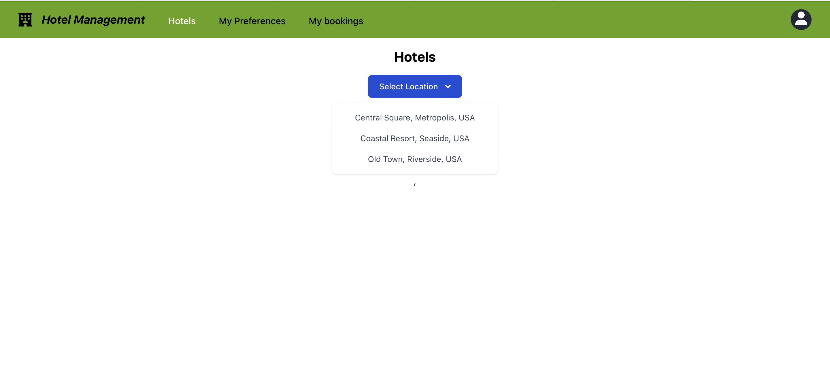

User could select the location and book the hotels.

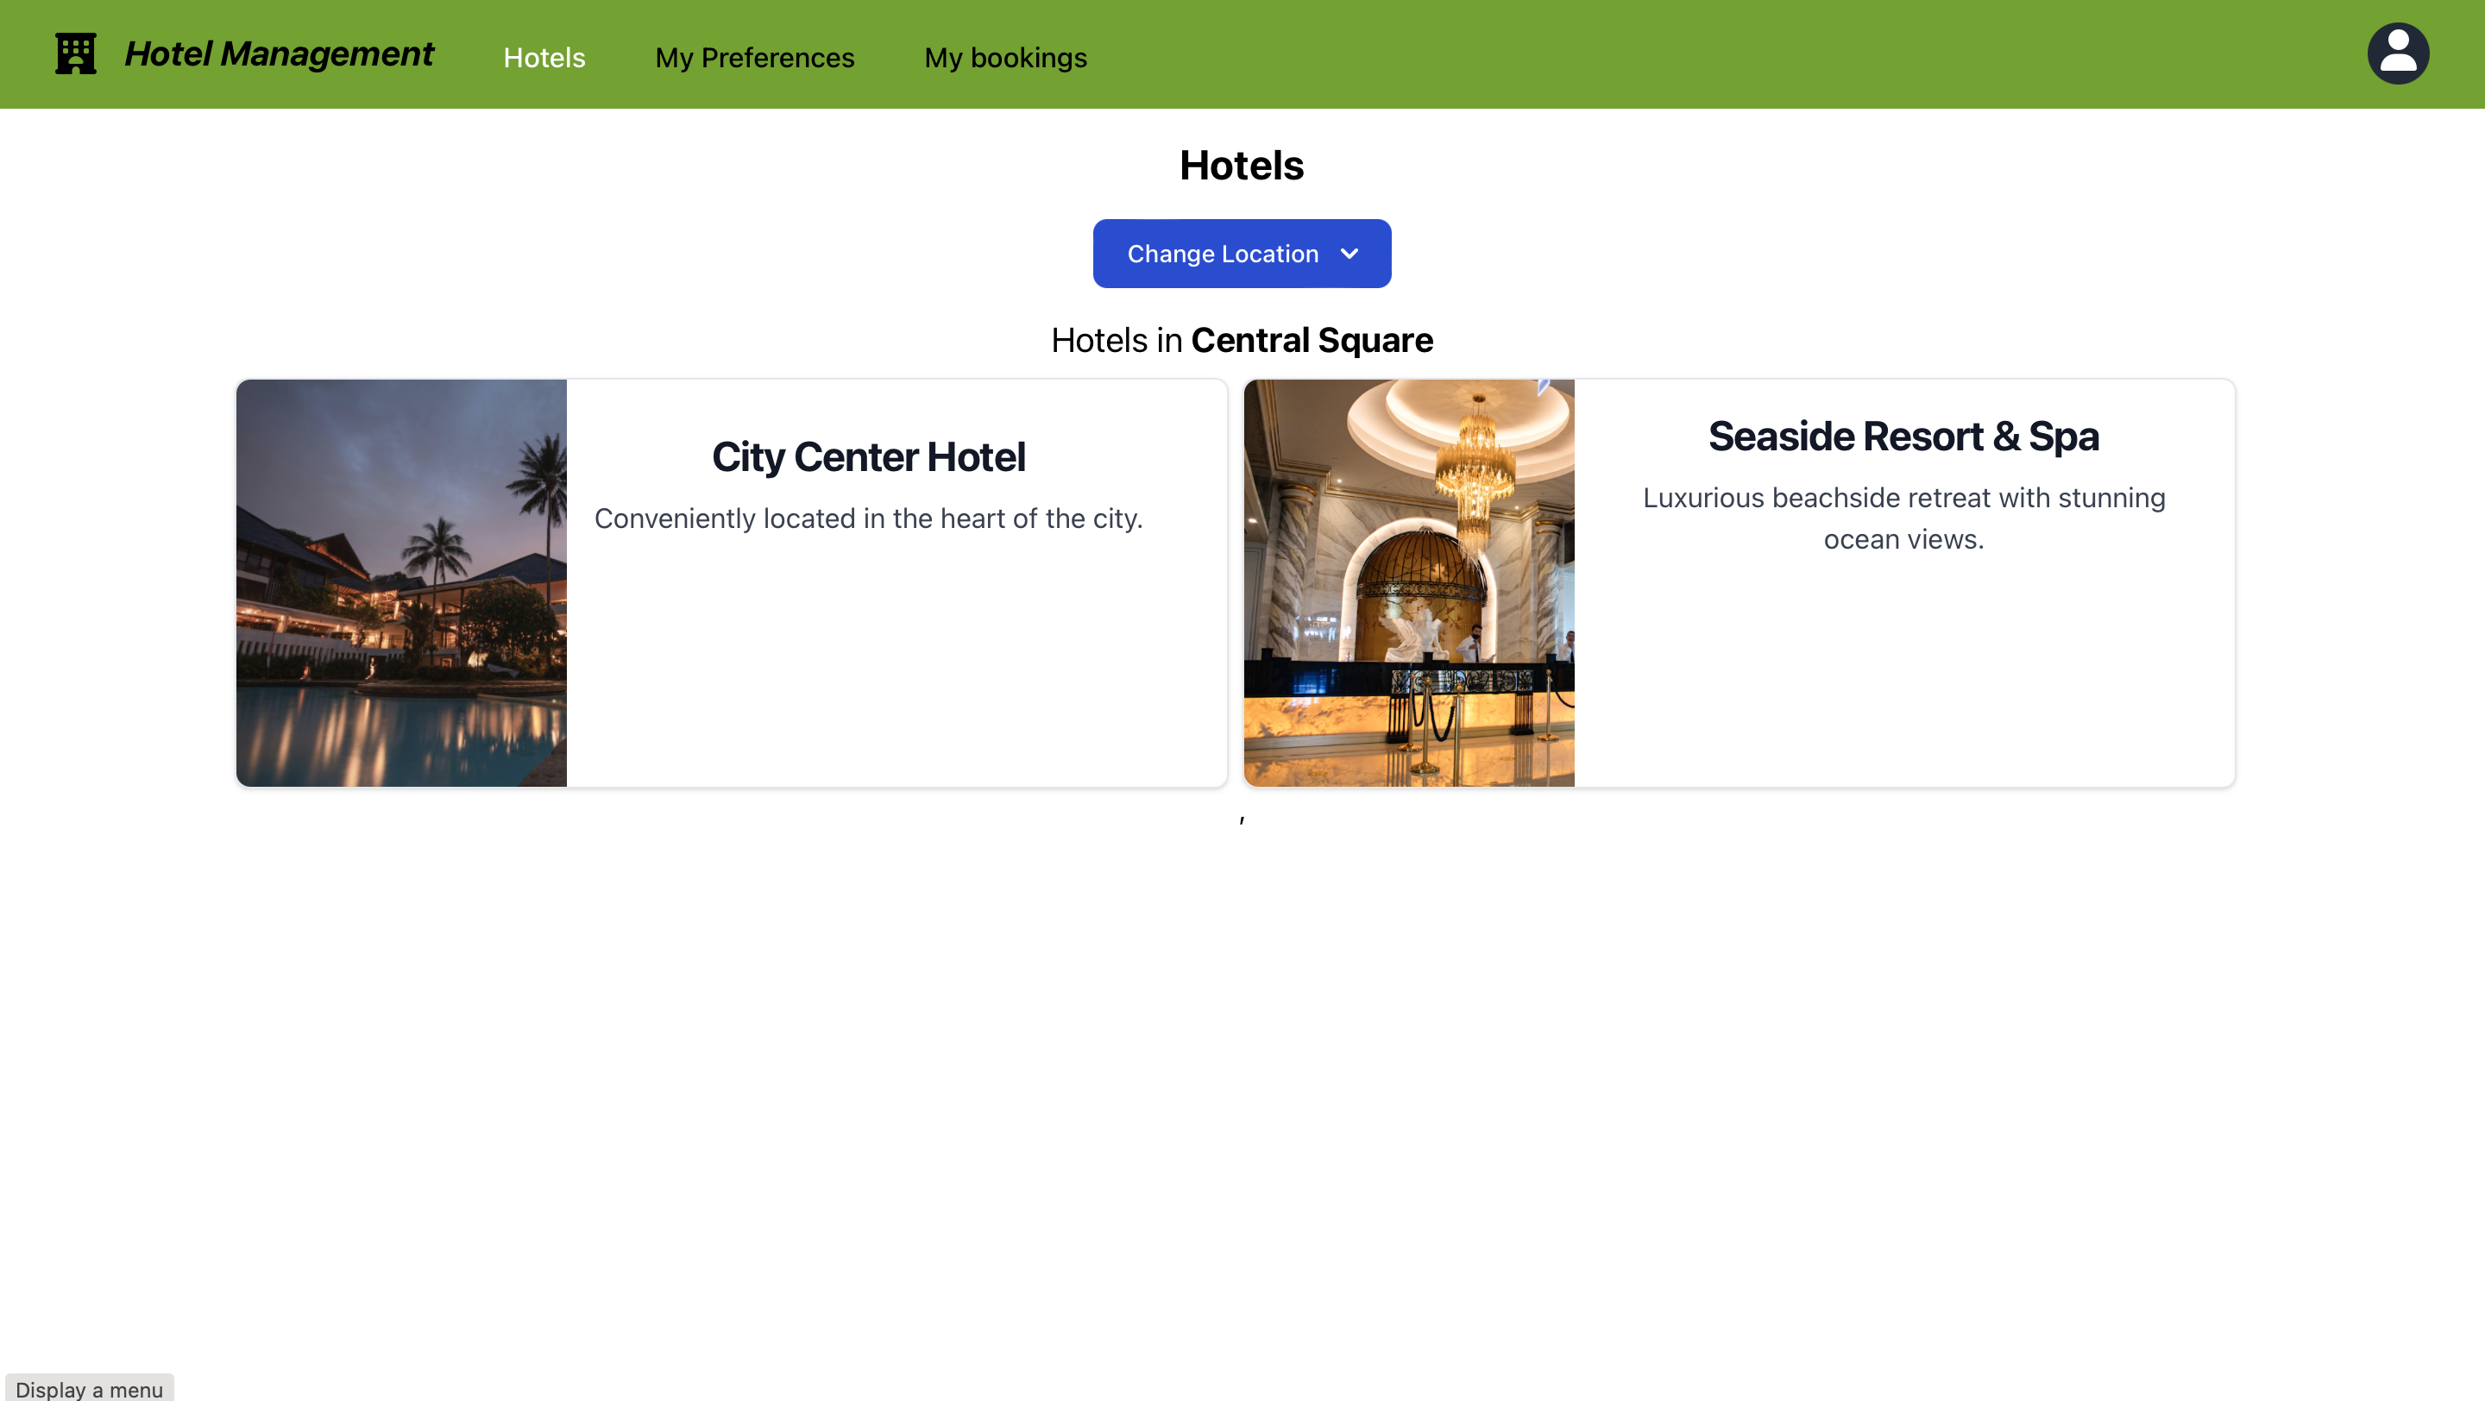

Select the Amenities and it will show the price for each extra amenity. And user should select Number of rooms and number of nights

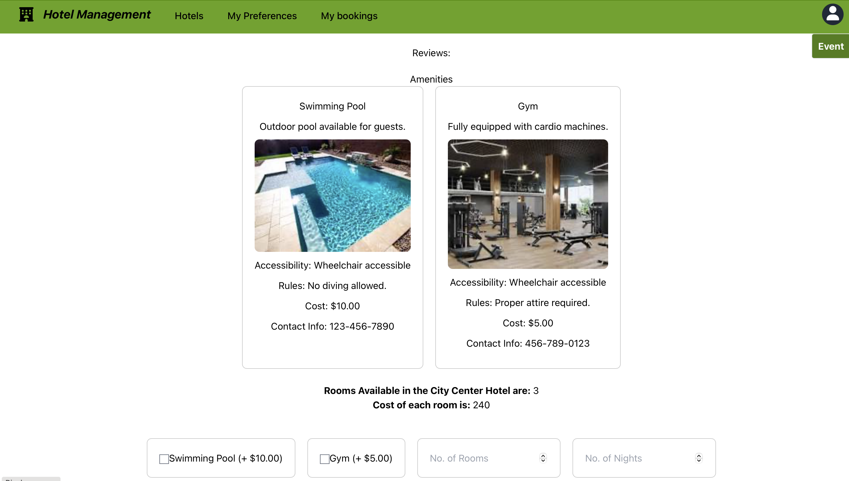

Pop up will show after completing the booking.

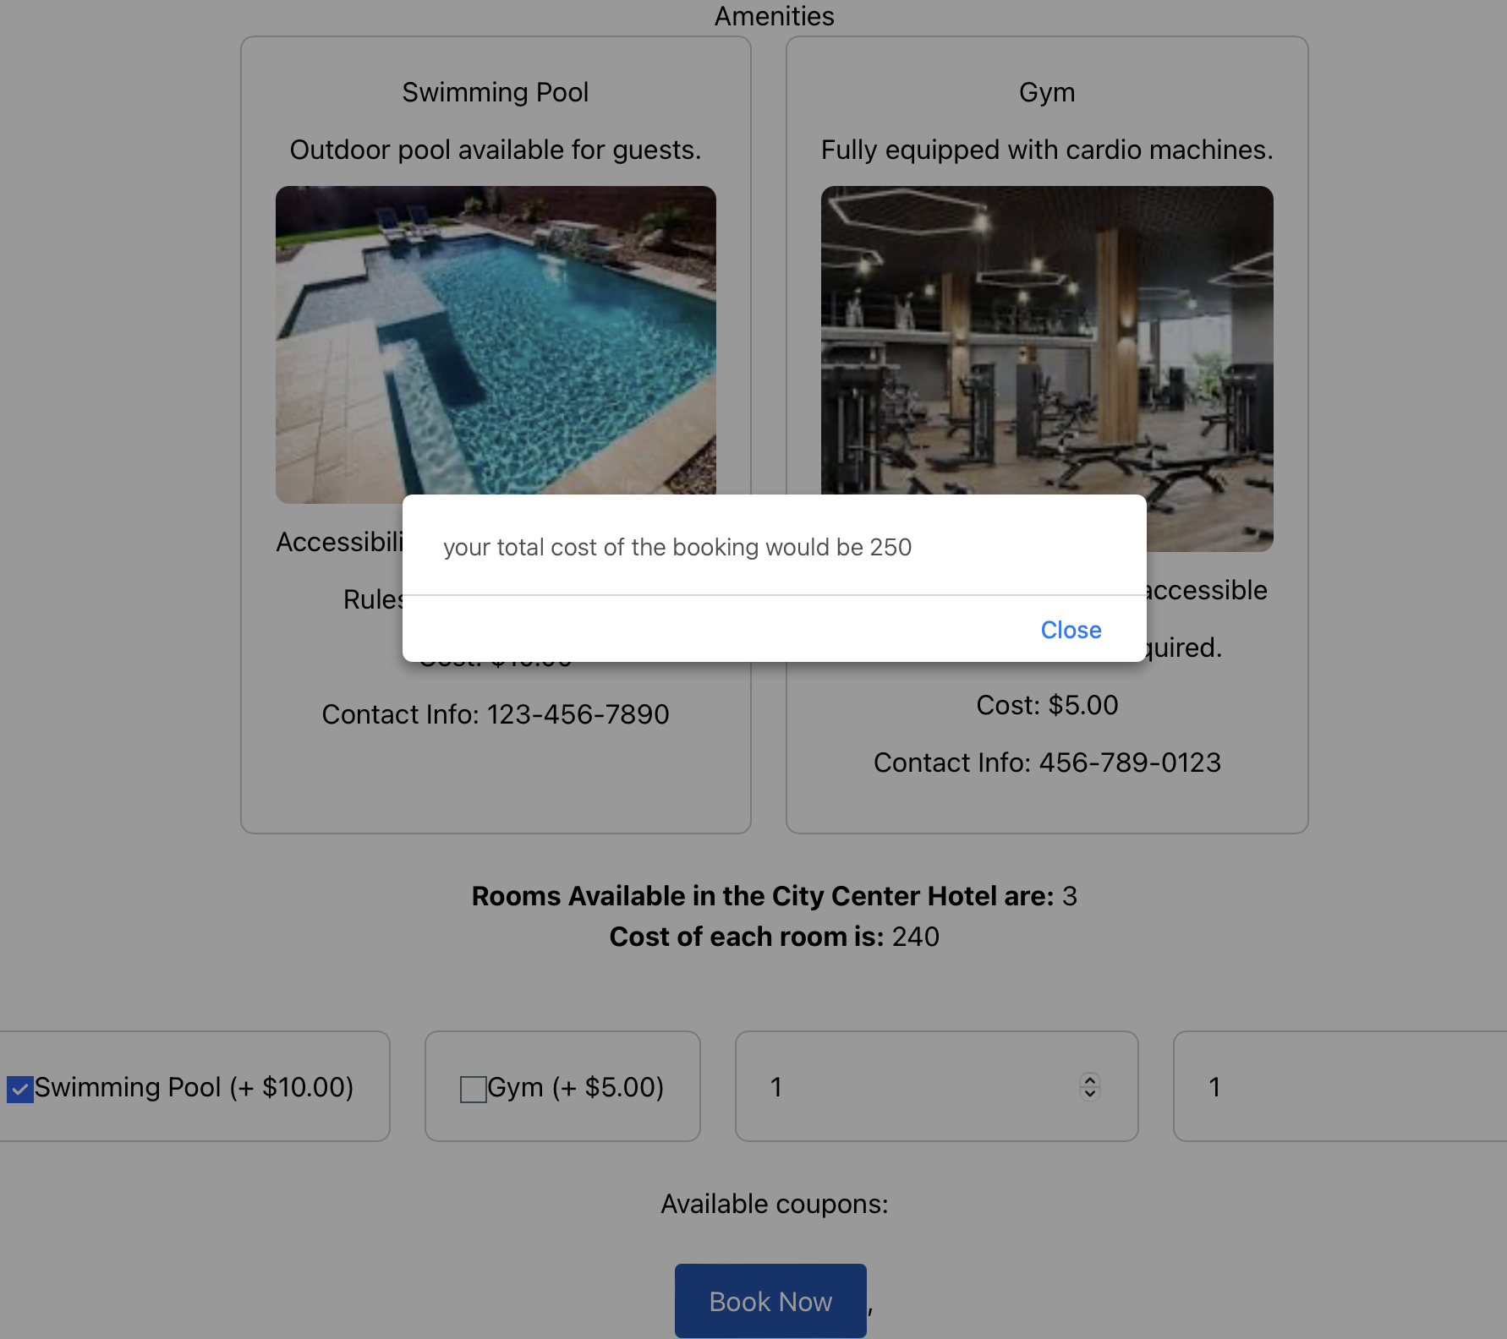

**Booking confirmation**

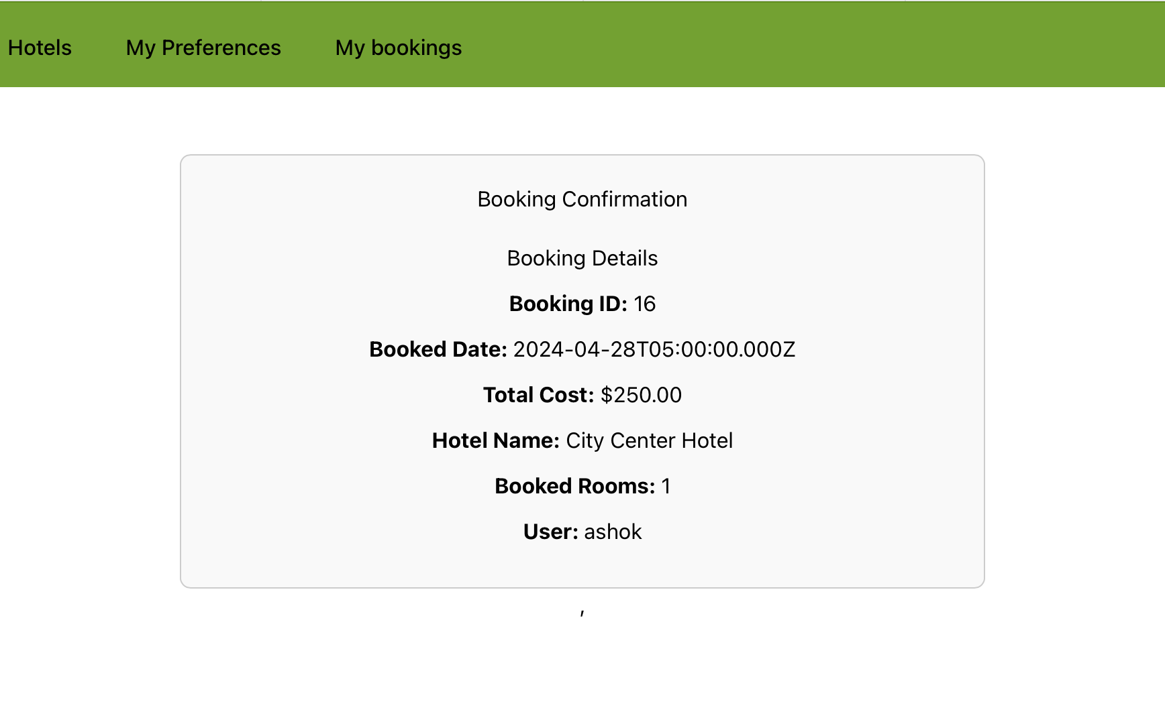

Here is another feature i.e update the preferences.

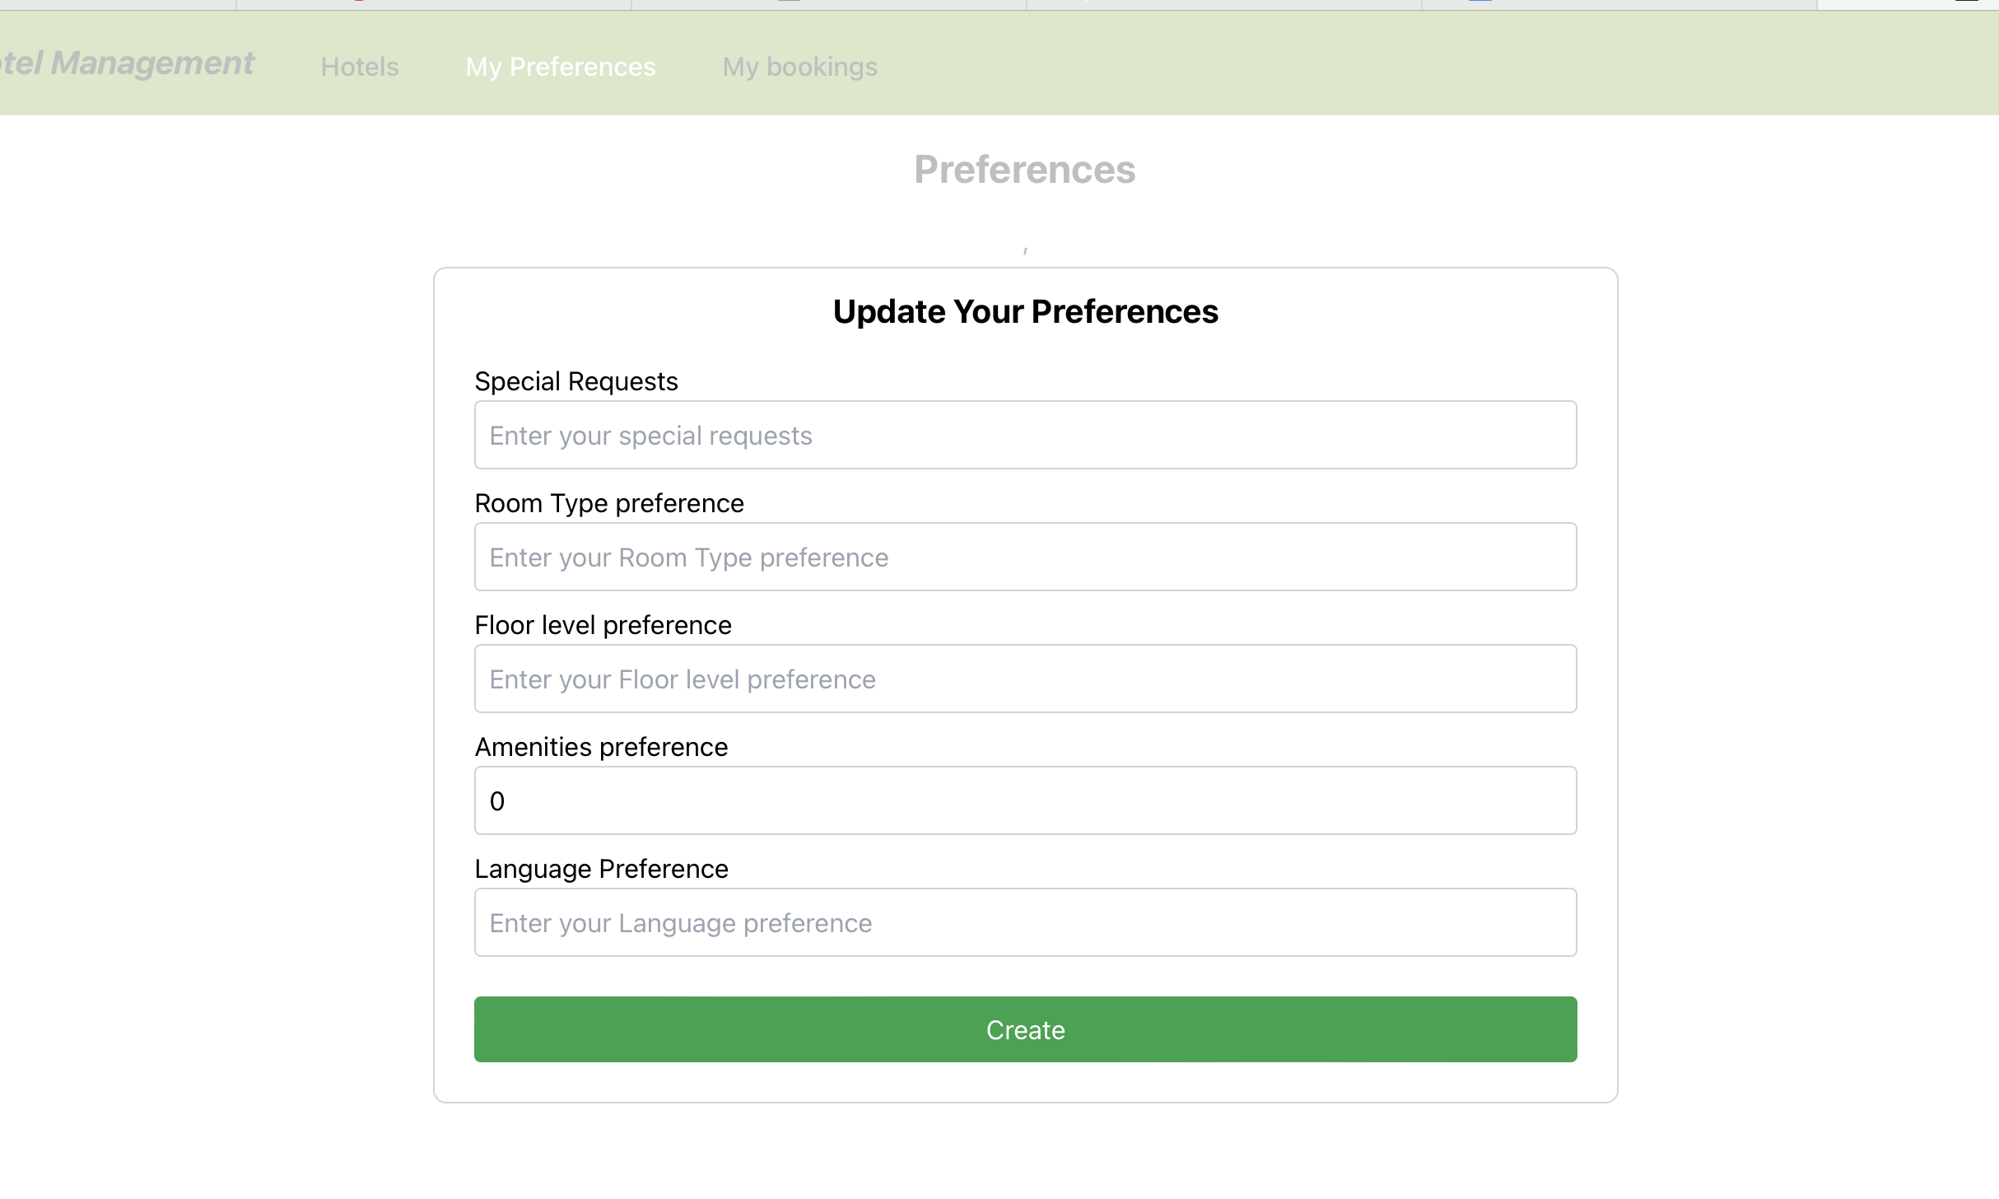

**Admin Login**

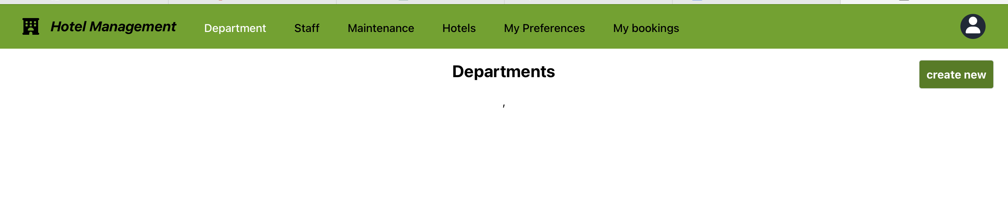

Admin should create the department details by giving Name, Description and Contact Info.

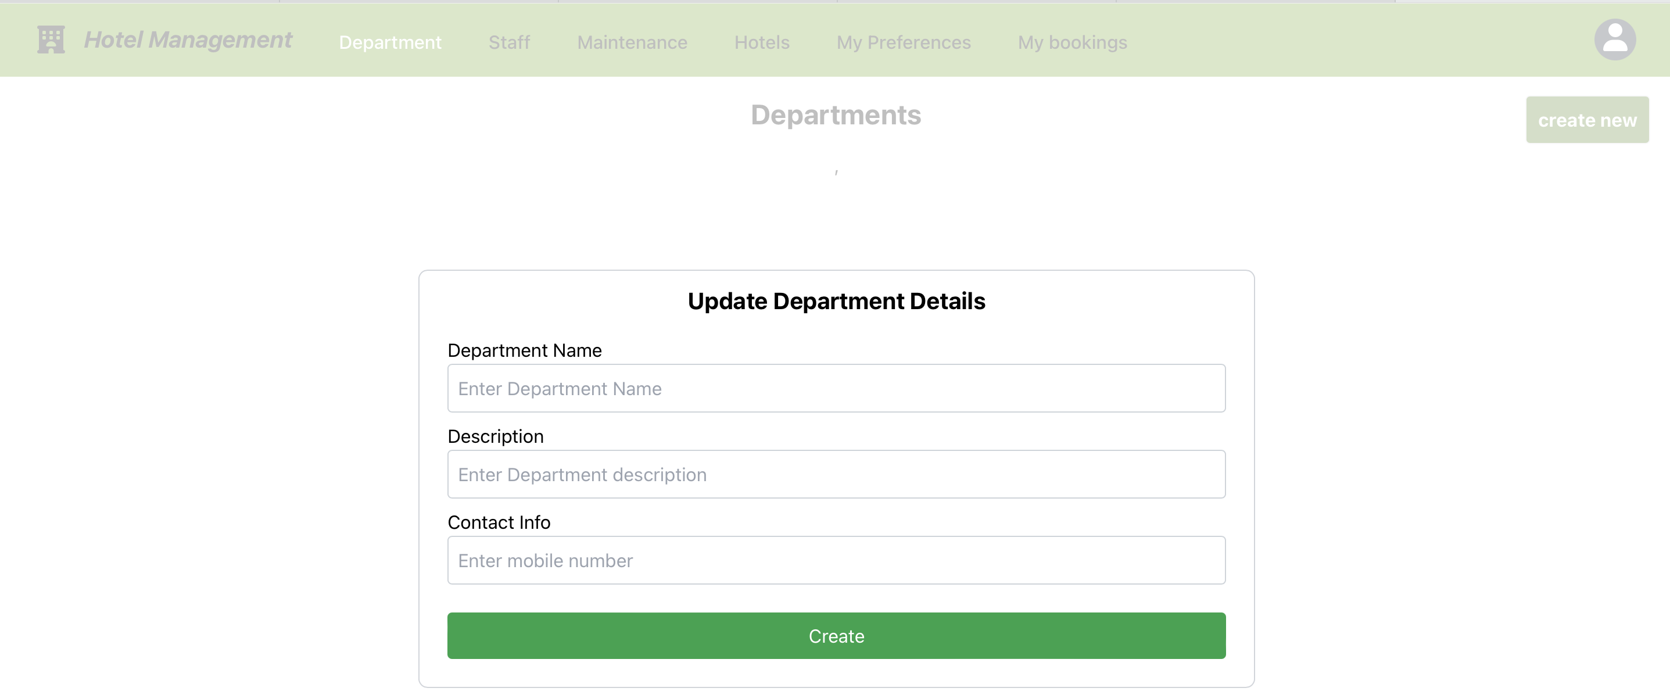

Create the Staff Details using below details.

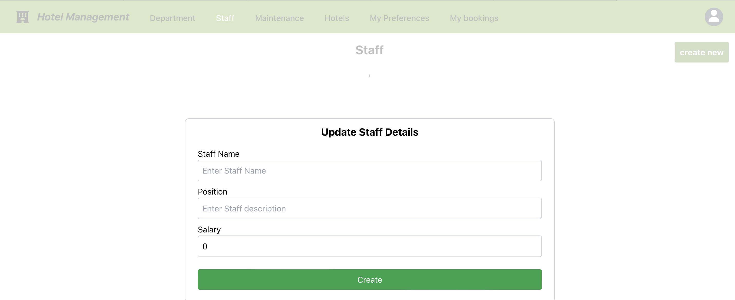

Create the Maintenance details and below are the mandatory details for creating.

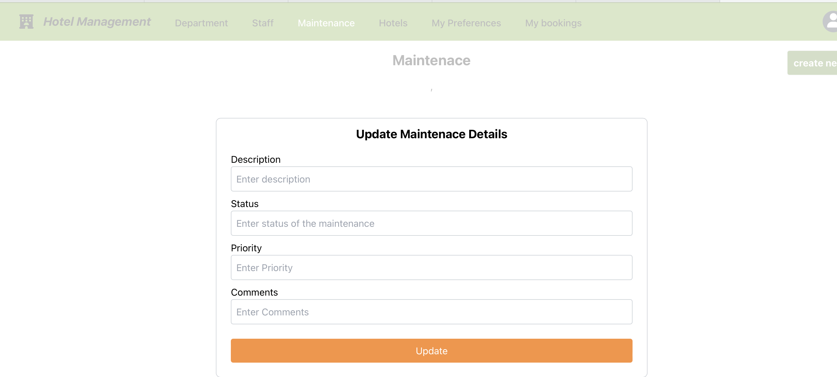

Update and Delete the Hotel details based on location preferences.

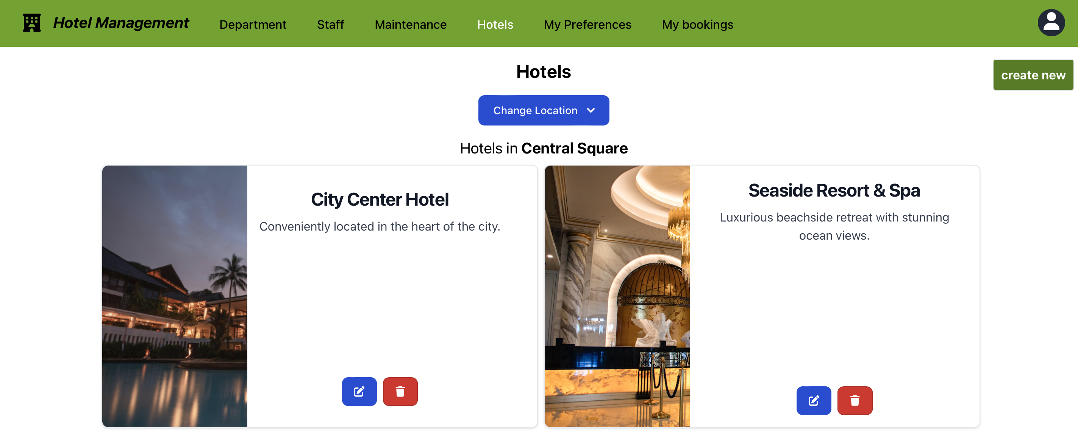

Create the Preferences.

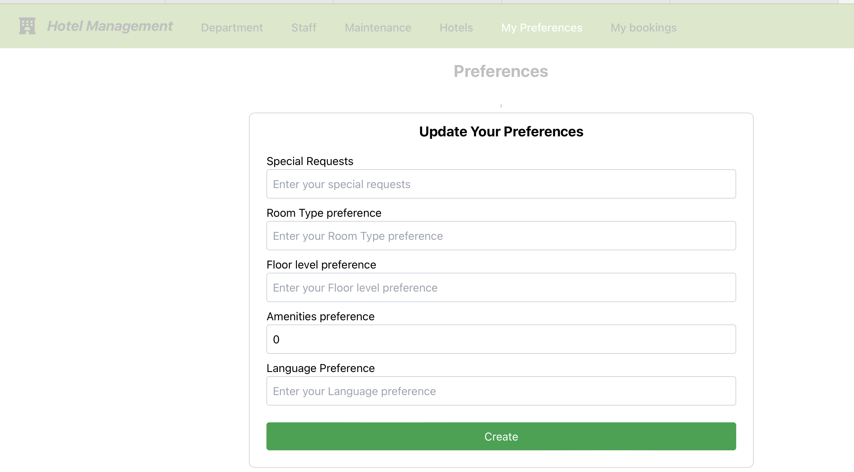

Admin sign out

